**Strictly Business**

Elaboration Phase Spec

CIS 320-02

Dr. Barker

12/6/2019

By: Emily Robertson, Emily Corso, Will Grise, Chase Sellers, Braedan Merriman, & Shane Bell

**System Requirements:**

System Requirements are important to document so that we can give the client exactly what they need and a product that they will actually utilize. The Requirements contain the behavior, attributes, and the properties that the future system will have. It is essential to gain approval from the Business on these requirements so that we are on the same page and we can move further into development.

Functional Requirements

Customers

1. The system will allow customers to view their membership online

2. The system will give the customers the ability to pay for their membership online

3. The system will allow customers to view the status of their locker rental online

4. The system will allow customers to pay for their locker rental online

5. The system will allow customers to reserve a specific locker

6. The system will allow for customers to bundle the locker and membership together by semester

7. The system will allow customers to take surveys on the site

SRC

8. The system will allow the user to track gym usage via a database

9. The system will allow the user to send out email blasts

10. The system will allow the user to send out surveys via email

11. The system will allow the user to track machine maintenance via a database

12. The system will allow the user to maintain adequate records for locker rentals and memberships

13. The system will generate reports for the user

14. The system will allow entry of usage data via a tablet

15. The system will work when the user enters a WIFI dead zone in the SRC

Database

16. The system will allow the user to add records to the database

17. The system will allow the user to remove records to the database

18. The system will allow the user to modify records to the database

19. The system will alert the user of invalid entries

20. The system will notify the user if a membership has expired

21. The system will notify the user if a locker rental has expired

Payment Systems

22. The payment system will verify the transactions are accepted

23. The payment system will be able to be integrated with the website we are creating for this project

Non-Functional Requirements

24. The system will be created using WordPress

25. The system will meet set security standards

26. The system will use a SQL database

27. The system will have a backup

28. The system will be able to recover from the backup

29. The system will be a website

30. The system will be a graphical user interface

**Use Case Diagrams:**

Use Case Diagrams are useful for identifying who is doing which tasks. There are several parts to a Use Case Diagrams such as the actors, the use cases, the system boundary, and the relationship. The actors are individuals involved with the systems and they can be actual people or an external system. The use case describes how the actors use the system to accomplish a particular goal. The relationship is between the actors and the use cases. The system boundary defines the system used and their relation to the world around it. By having this diagram, the client will be able to define which actors will be completing which activities with the new system implemented.

Use Cases 1-5 Diagram

This use case diagram demonstrates the associations between the member/employee and the use cases for use cases 1 through 5.

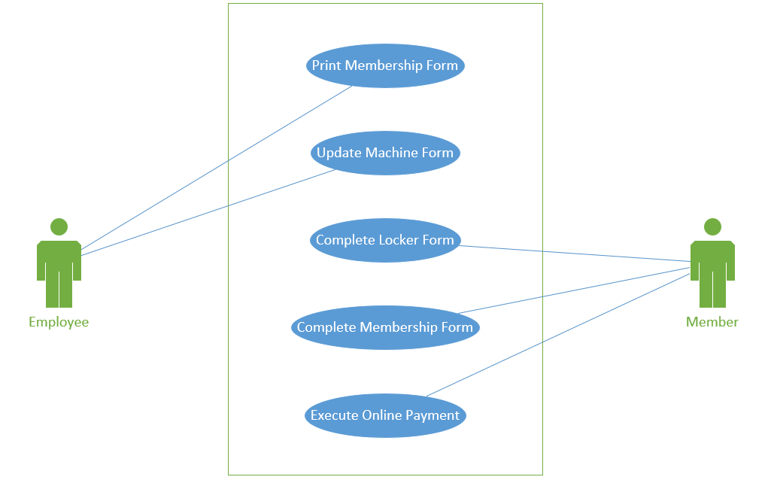

Use Cases 6-10 Diagram

This use case diagram demonstrates the associations between the member/employee and the use cases for use cases 6 through 10.

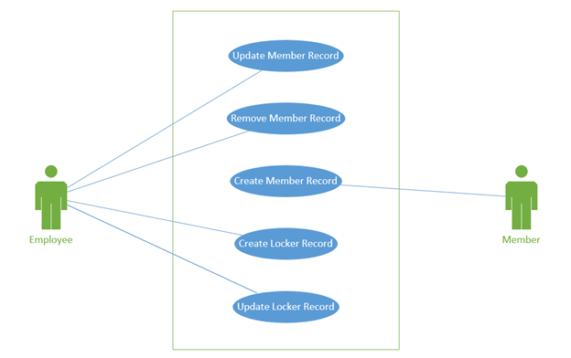

Use Cases 11-15 Diagram

This use case diagram demonstrates the associations between the member/employee and the use cases for use cases 11 through 15.

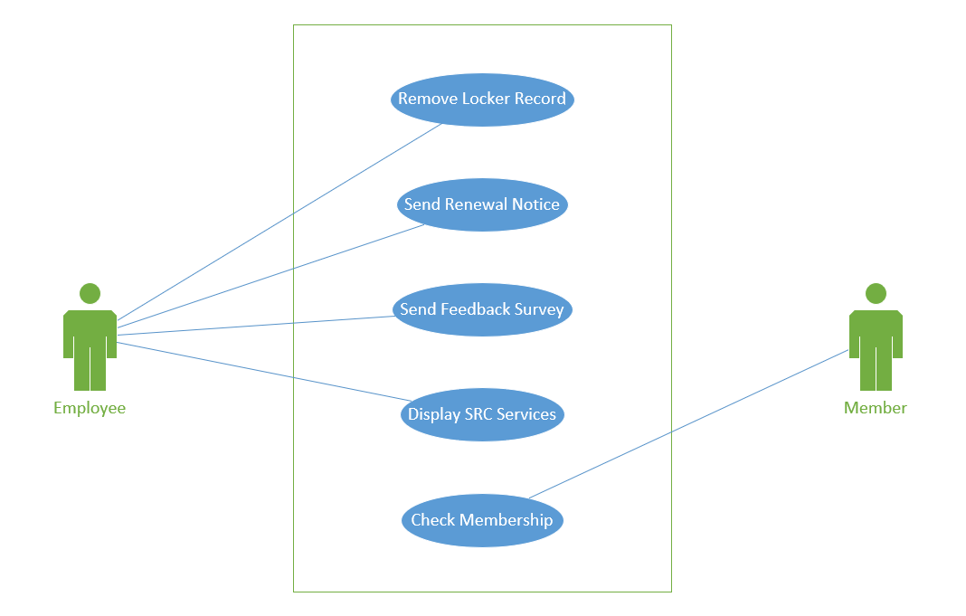

Use Cases 16-20 Diagram

This use case diagram demonstrates the associations between the member/employee and the use cases for use cases 16 through 20.

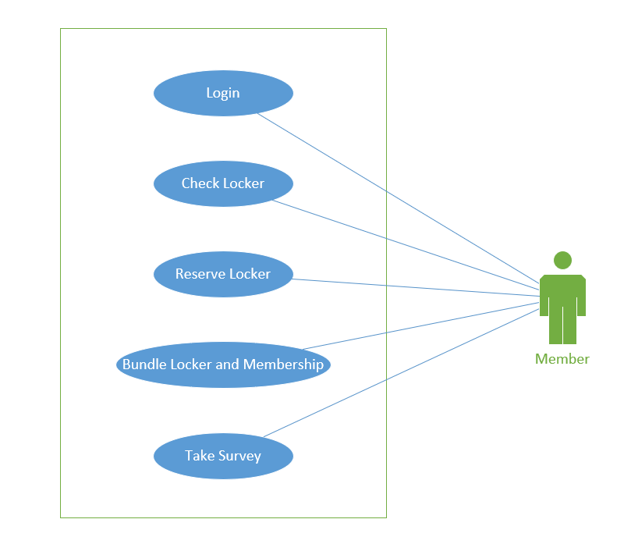

Use Cases 21-25 Diagram

This use case diagram demonstrates the associations between the member/employee and the use cases for use cases 21 through 25.

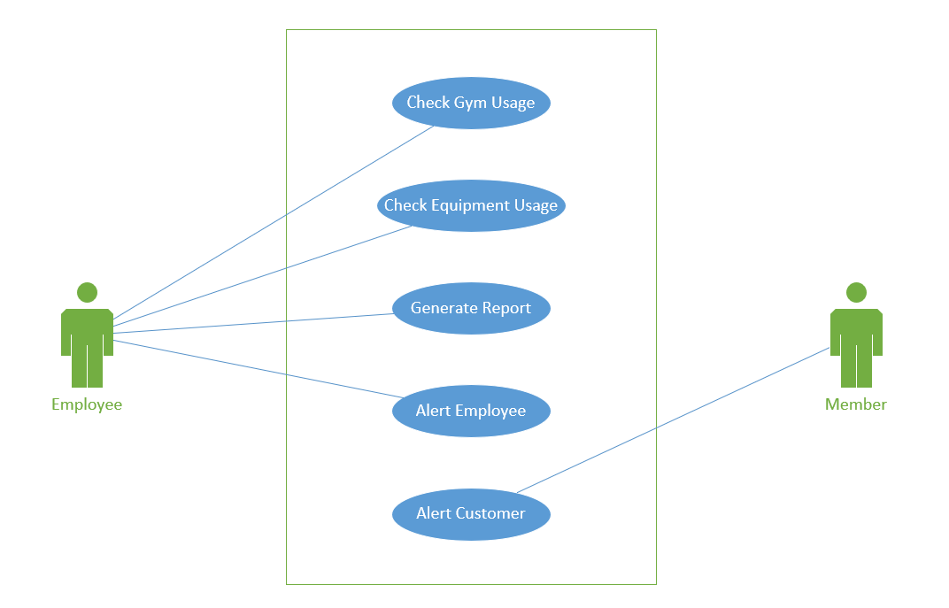

Use Cases 26-30 Diagram

This use case diagram demonstrates the associations between the member/employee and the use cases for use cases 26 through 30.

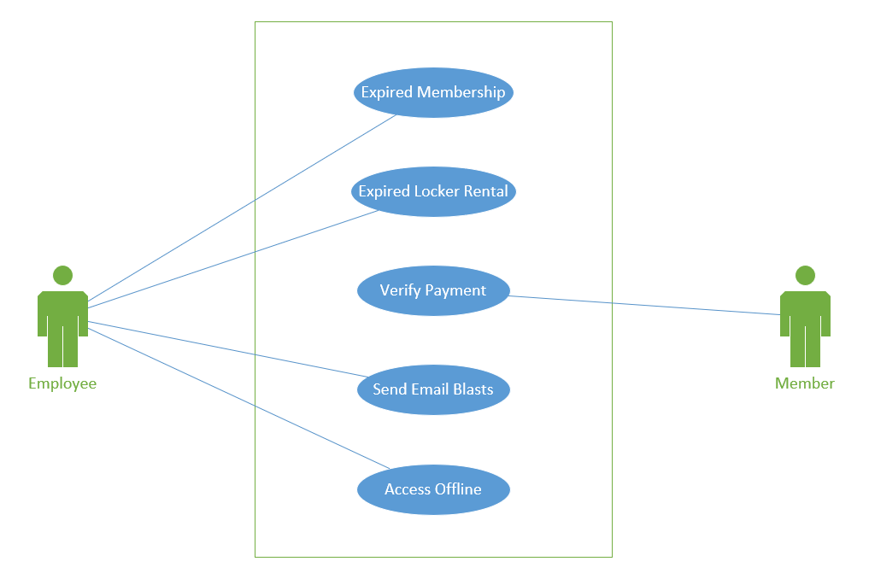

**Trace Matrix:**

A traceability matrix is a document used to assist in determining if the current project’s requirements, scope, and deliverables are still on track. We can compare this to the baseline to determine what we need to improve on and see what we are doing well. This matrix can be used during all phases of the project to assess what still needs to be completed and what is finished. This matrix helps us ensure the business client that we are working on the project and getting closer to the finish date. This Trace Matrix should be created at the beginning of the project so that the team can be prepared for the future.

**Use Cases:**

Use cases are helpful because they show a written description of what tasks the users will perform and how they will perform them. It outlines how a system will behave from the user’s point of view. It gives a useful description on the tasks the business client wants in their system. Each use case has a description, a main flow, and alternative flow, special requirements, preconditions and postconditions, and extension points. These parts come together to identify areas that could fail and it can help a team determine what is really needed in their desired system.

**Use Case Specification #1: Print Membership Form**

# **Print Membership Form**

## **Brief Description**

This use case allows the employee to print out the completed membership forms of the members in order to maintain a physical record if they so choose.

# **Flow of Events**

## **Basic Flow**

1. The employee navigates to the website.

2. The employee logs in.

3. The employee navigates to their dashboard.

4. The employee selects the appropriate member.

5. The employee views their membership form.

6. The employee clicks print.

## **Alternative Flows**

1. The employee doesn’t find the member they are looking for.
2. The employee views the membership but does not print.

# **Special Requirements**

1. Must work on both desktop and mobile operating systems.
2. Must work on modern browsers, i.e. Chrome, Firefox, Safari.
3. Must fit on a standard size piece of copy paper when printed.

# **Pre-conditions**

1. The website must be up for the employee to log-in.
2. The database must be working for the employee to access the membership forms.

# **Post-conditions**

1. The employee has a printed physical copy of the desired membership form.

**Use Case Specification #2: Update Machine Form**

# **Update Machine Form**

## **Brief Description**

This use case allows an employee to fill out the current Machine Maintenance Form, on a tablet or laptop. This is useful because it will save the employees time, and it will also save the business materials.

# **Flow of Events**

## **Basic Flow**

1. The employee navigates to the website.
2. The employee logs in.
3. The employee navigates to their dashboard.
4. The employee selects the machine form.
5. The employee conducts their inspection.
6. The employee request maintenance for relevant machines.
7. The employee hits record to update the machine form.

## **Alternative Flows**

1. The employee finds no machine in need of maintenance so only updates that the inspection has taken place.

# **Special Requirements**

1. Must work on both desktop and mobile operating systems.
2. Must work on modern browsers, i.e. Chrome, Firefox, Safari
3. Must be able to be saved upon completion.
4. Must be able to back up to the database.
5. Date and Time should be filled out automatically.
6. If the employee is out of Wi-Fi range, the data should be able to be stored locally until they are able to record it to the database.

# **Pre-conditions**

1. The website must be up for the user to log-in.
2. The database must be up for the user to grab the most recent inspection information.

# **Post-conditions**

1. The employee has updated the machine form and recorded it to the database.

**Use Case Specification #3: Complete Locker Form**

# **Complete Locker Form**

## **Brief Description**

This use-case allows the member to fill out the locker form online. This is useful because the members will be able to reserve lockers without having to go into the SRC to do it.

# **Flow of Events**

## **Basic Flow**

1. The member navigates to the SRC website.
2. The member logs in.
3. The member clicks “Locker Rental”
4. The member completes the Locker Rental Form.
5. The member continues to payment.

## **Alternative Flows**

1. The member accesses the locker form from the membership form.
2. The member renews the locker based off the previous completed form.

# **Special Requirements**

1. Must work on both desktop and mobile operating systems.
2. Must work on modern browsers. i.e. Chrome, Firefox, Safari.
3. Must be able to be saved upon completion.

# **Pre-conditions**

1. The website must be up for the user to access it.
2. The user must be an active member of the SRC.
3. The user must be logged-in.

# **Post-conditions**

## **Post-condition One**

1. The locker rental form information is sent to the database upon completion.

## **Post-condition Two**

1. The member is navigated to the payment gateway upon completion of the form.

**Use Case Specification #4: Complete Membership Form**

# **Complete Membership Form**

## **Brief Description**

This use case allows a member/potential member to go onto the website and fill out a membership form. This is useful for those who would rather fill out the membership form without having to go to the physical location to turn in a form.

# **Flow of Events**

## **Basic Flow**

1. The member navigates to the website.
2. The member selects “Online Membership Form”
3. The member completes the Membership Form.
4. The member continues to payment.

## **Alternative Flows**

1. The member renews the membership based off the previous completed form.

# **Special Requirements**

1. Must work on both desktop and mobile operating systems.
2. Must work on modern browsers, i.e. Chrome, Firefox, Safari.
3. Must fit on as standard size piece of copy paper when printed.
4. Must be able to be saved upon completion.

# **Pre-conditions**

1. The website must be up for the user to access it.

# **Post-conditions**

1. The user will be able to continue to online payment for their membership.

**Use Case Specification #5: Execute Online Payment**

# **Execute Online Payment**

## **Brief Description**

This use case allows a member/potential member to go to the website and pay for their membership or locker rental through a payment gateway. This is useful because a member may not have cash with them or may not want to come in to the SRC to pay for their membership or locker.

# **Flow of Events**

## **Basic Flow**

1. The member navigates to the website.

2. The member selects “Make a Payment.”

3. The member fills out the payment form.

4. The system directs the member to the payment gateway.

5. The member inputs payment information.

6. The member completes the payment.

7. The member is offered a receipt.

## **Alternative Flows**

1. The member proceeds to payment after filling out the online membership form.
2. The member checks that they would like a locker when paying for their membership and is sent to the locker form before proceeding with payment.

# **Special Requirements**

1. Must work on both desktop and mobile operating systems.
2. Must work on modern browsers, i.e. Chrome, Firefox, Safari.
3. Must be able to print the receipt or get it via email.

# **Pre-conditions**

1. The website must be up for the user to pay through the payment gateway.
2. The member must have a locker rental or membership to pay for.

# **Post-conditions**

1. The member has successfully paid for their membership/locker.
2. The member has a physical copy of their receipt or one in their email
3. The membership or locker rental shows that it has been paid for in the database.

**Use Case Specification #6: Update Locker Records**

**1.** **Use-Case Name**

**1.1** **Brief Description**

This use case allows an employee to delete a member record.

**2.** **Flow of Events**

**2.1** **Basic Flow**

1. The employee navigates to the website.

2. The employee logs in to their admin account

3. The employee goes to the admin tab

4. The employee clicks on manage members

5. The employee then clicks on the member whose locker rental needs to be changed

6. The employee then enters the information that needs to be changed

7. The employee then confirms the entry

9. System then updates the record

10. Use case ends

**2.2** **Alternative Flows**

**2.2.1** **Incorrect Information**

If the employee enters the wrong information, the system will prevent the record from updating

**3.** **Special Requirements**

**3.1** **Must work on modern browsers, i.e. Chrome, Firefox, Safari.**

**4.** **Pre-conditions**

**4.1** **Pre-condition One**

The website must be up for the employee to access the form.

**5.** **Post-conditions**

**5.1** **Post-condition One**

1.The locker record is updated

**Use Case Specification #7: Update User Records**

**1.** **Use-Case Name**

**1.1** **Brief Description**

This use case allows an employee to edit a member’s information. This will allow the employee to change the member’s information and the status of their membership

**2.** **Flow of Events**

**2.1** **Basic Flow**

1. The employee navigates to the website.

2. The employee logs in to their admin account

3. The employee goes to the admin tab

4. The employee clicks on manage members

5. The employee then clicks on the member whose information needs to be changed

6. The employee then changes the necessary information

7. The employee then saves the changes

8. Message appears are you sure you want to save these changes

9. Employee hits yes

10. System then updates the record

11. Use case ends

**3.** **Special Requirements**

**3.1** Must work on modern browsers, i.e. Chrome, Firefox, Safari.

**4.** **Pre-conditions**

*4.1 Pre-condition One*

The website must be up for the employee to access the form.

**5.** **Post-conditions**

*5.1 Post-condition One*

The member record is updated

**Use Case Specification #8: Delete Locker Records**

**1.** **Use-Case Name**

**1.1** **Brief Description**

This use case allows an employee to delete a member’s locker. This is useful in identifying issues with the process of deleting user records and should allow for the employees to have an easier time in deleting said records.

**2.** **Flow of Events**

**2.1** **Basic Flow**

1. The employee navigates to the website.

2. The employee logs in to their admin account

3. The employee goes to the admin tab

4. The employee clicks on manage members

5. The employee then enters in the locker number whose rental is to be deleted

6. The employee then hits the delete button

7. The employee then has to hit confirm on a banner that appears confirming the deletion

8. Employee hits confirm

9. System then deletes the record

10. Use case ends

**3.** **Special Requirements**

*3.1 Must work on modern browsers, i.e. Chrome, Firefox, Safari.*

**4.** **Pre-conditions**

*4.1 Pre-condition One*

The website must be up for the employee to access the form.

**5.** **Post-conditions**

*5.1 Post-condition One*

The member’s locker record is deleted

**6.** **Extension Points**

*6.1 Cancel*

The employee cancels the deletion of the locker record

**Use Case Specification #9: Remove User Records**

**1.** **Use-Case Name**

**1.1** **Brief Description**

This use case allows an employee to delete a member record. This is useful in identifying issues with the process of deleting user records and should allow for the employees to have an easier time in deleting said records.

**2.** **Flow of Events**

*2.1 Basic Flow*

1. The employee navigates to the website.

2. The employee logs in to their admin account

3. The employee goes to the admin tab

4. The employee clicks on manage members

5. The employee then clicks on the member whose information needs to be deleted

6. The employee then hits the delete button

7. The employee then has to hit confirm on a banner that appears confirming the deletion

8. Employee hits confirm

9. System then deletes the record

10. Use case ends

*2.2 Alternative Flows*

**3.** **Special Requirements**

3.1 Must work on modern browsers, i.e. Chrome, Firefox, Safari.

**4.** **Pre-conditions**

*4.1 Pre-condition One*

The website must be up for the employee to access the form.

**5.** **Post-conditions**

*5.1 Post-condition One*

1.The member record is deleted

**6.** **Extension Points**

*6.1 Cancel*

The employee cancels the deletion of the user record

**Use Case Specification #10: Creating a User Account**

**1.** **Use-Case Name**

**1.1** **Brief Description**

This use case allows an employee to delete a member record. This is

**2.** **Flow of Events**

*2.1 Basic Flow*

1. The customer navigates to the website

2. The customer hits the create an account button

3. A window pops up asking the customer for their information

4. The customer enters in their first name

5. The customer enters their last name

6. The customer enters in their email address, which will be the user name for the account

7. The customer enters in their address

8. The customer enters in their sex

9. The customer enter in their race

10. The customer enters in the password for their account

11. The customer submits the information

12. The system creates the account

13. Use Case ends

**2.2** **Alternative Flows**

*2.2.1 Incorrect Information*

The system will issue an error if fields are incorrectly formatted or missing information

**3.** **Special Requirements**

**3.1** Must work on modern browsers, i.e. Chrome, Firefox, Safari.

**4.** **Pre-conditions**

*4.1 Pre-condition One*

The website must be up for the customer to access the form

**5.** **Post-conditions**

*5.1 Post-condition One*

The customer account is created

**Use Case Specification #11: Remove Locker Record**

**1.** **Remove Locker Record**

**1.1** **Brief Description**

This use case allows an employee to go onto the website and delete a member’s Locker Rental Records. This is useful for those who don’t feel they have the technical skills to fill out a form online and allows the members to print out completed forms for the physical records if necessary.

**2.** **Flow of Events**

**2.1** **Basic Flow**

1. The employee navigates the website.

2. The employee accesses the member’s records.

3. The employee clicks the “Locker” dropdown.

4. The employee clicks the “Remove” Button.

5. The member is notified of the removal.

**2.2** **Alternative Flows**

1. The employee navigates the binder.

2. The employee accesses the member’s records.

3. The employee finds out if they have a Locker Rental.

4. The employee erases the Locker field.

5. The member is notified of the removal.

**3.** **Special Requirements**

## 1. Must work on both desktop and mobile operating systems.

## 2. Must work on modern browsers, i.e. Chrome, Firefox, Safari.

**4. Pre-conditions**

*4.1 Pre-condition One*

The member must already have a Locker Rental.

**5. Post-conditions**

5.1 No Post- Conditions needed.

**Use Case Specification #12: Membership Renewal Notice**

**1. Membership Renewal Notice**

**1.1 Brief Description**

This use case allows an employee to send a member a notice which will state that it is time to rent. This is useful because it helps members keep track of when they need to renew their membership. Currently there is no way for a member to check when their membership expires except for asking an employee in person.

**2. Flow of Events**

*2.1 Basic Flow*

1. The employee accesses the member’s records.

2. The employee checks the status of the membership.

3. The employee opens the email account.

4. The employee clicks on the email template for “Membership Renewal”

5. The employee sends the email to the member.

6. The member is notified of their Membership Renewal.

## *2.2 Alternative Flows*

## 1. The employee accesses the member’s record in a binder.

## 2. The employee checks the status of the membership on the sheet.

3. The employee opens the email account.

4. The employee clicks on the email template for “Membership Renewal”

5. The employee sends the email to the member.

6. The member is notified of their Membership Renewal.

**3. Special Requirements**

## 1. Must work on both desktop and mobile operating systems.

## 2. Must work on modern browsers, i.e. Chrome, Firefox, Safari.

## **4. Pre-conditions**

# *4.1 Pre-condition One*

The member must already have a membership with the SRC.

**5. Post-conditions**

*5.1 Post-Condition One*

The member must renew their membership if they wish to continue using the SRC’s services

**Use Case Specification #13: Membership Feedback Survey**

**1. Membership Feedback Survey**

**1.1 Brief Description**

This use case allows an employee to send out a feedback survey to all customers to check on the performance of the SRC and where the business can make improvements or enhancements. This is helpful because it lets the customers voice their opinion to the SRC and tell the business what is working and what is not.

**2. Flow of Events**

*2.1 Basic Flow*

1. The employee accesses the member’s records.

2. The employee copies a member’s email address.

3. The employee opens the email account.

4. The employee clicks on the email template for “Feedback Survey”

5. The employee paste a member’s email address.

6. The employee clicks “Send” to the email address of the member.

*2.2 Alternative Flows*

1. The employee accesses the member’s record in a binder.

2. The employee checks the status of the membership on the spreadsheet.

3. The employee opens the email account.

**3. Special Requirements**

1. Must work on both desktop and mobile operating systems.

2. Must work on modern browsers, i.e. Chrome, Firefox, Safari.

**4. Pre-conditions**

*4.1 Pre-condition One*

The website must be up for the employee to check the member records

**5. Post-conditions**

*5.1 Post-Condition One*

The SRC must have a way to store all of the Feedback Survey Data.

**Use Case Specification #14: Display SRC Services**

**1. Display SRC Services**

**1.1 Brief Description**

This use case allows an employee to update the SRC website to show new services that they will offer.

**2. Flow of Events**

*2.1 Basic Flow*

1. The employee accesses the website template.

2. The employee adds the new services offered.

3. The employee clicks save.

4. The website is updated with the new services.

*2.2 Alternative Flows*

1. The employee accesses the website template.

2. The employee adds the new services offered.

3. The employee clicks save.

4. The employee notices a spelling error.

5. The employee will edit the error.

6. The employee clocks save again.

7. The website is updated with the new services.

**3. Special Requirements**

1. Must work on both desktop and mobile operating systems.

2. Must work on modern browsers, i.e. Chrome, Firefox, Safari.

**4. Pre-conditions**

*4.1 Pre-condition One*

The website must be up for the employee to update the SRC Services.

**5. Post-conditions**

**5.1** No Post-Condition needed.

**Use Case Specification #15: Membership Check**

**1. Membership Check**

**1.1 Brief Description**

This use case allows a customer to check on the status of their membership and to see when their membership will expire. This will allow customers to check on the status of their membership manually from any device in virtually any place. This will be useful because members will know when they need to renew their membership and they won’t need to rely on employees to notify them.

**2. Flow of Events**

*2.1 Basic Flow*

1. The customer accesses the website.

2. The customers enters their username.

3. The customer enters in their password.

4. The customer clicks on the “Account” button.

5. The customer sees if their membership is active or not.

6. The customer sees when their membership expires.

*2.2 Alternative Flows*

1. The employee accesses the member’s record in a binder.

2. The employee checks the status of the membership on the spreadsheet.

3. The employee tells the customer about their account information in person.

**3. Special Requirements**

1. Must work on both desktop and mobile operating systems.

2. Must work on modern browsers, i.e. Chrome, Firefox, Safari.

**4. Pre-conditions**

*4.1 Pre-condition One*

There must be membership records (the member must have once had a membership with the SRC) so that the employee can check the status.

**5. Post-conditions**

*5.1 Post- Condition One*

The member will have the information needed to know if they need to renew their membership.

**Use Case Specification #16: Customer Web Login**

# **1.** **Customer Web Login**

## *1.1 Brief Description*

## This use case will allow a potential or current member to access the website through a username and password protected system. This will ensure that private user information is not accessed by anyone but the member themselves or employees of the SRC.

**2.** **Flow of Events**

## *2.1 Basic Flow*

## The current or potential member navigates to the SRC website.

## The current or potential member is then prompted to login with a username and password.

## The user can now access information specific to their account.

## *2.2 Alternative Flows*

### 2.2.1 First Alternative Flow

### The user navigates to the SRC website.

### The user is presented with the website homepage.

### The user navigates to the login page.

### The user is prompted to login with a username and password.

### The user enters their username.

### The user enters their password.

### The user submits their login.

### 2.2.2 Second Alternative Flow

### The user navigates to the SRC website

### The user navigates to the login page.

### The user enters their username.

### The user enters their password.

### The user submits.

### The user is given the error “Incorrect User or Password”.

### The user re-enters their information.

### 2.2.3 Third Alternative Flow

### The user navigates to the SRC website.

### The user navigates to the login page.

### The user does not enter their information.

### The user is redirected to the homepage due to inactivity.

# **3.** **Special Requirements**

# Customer Web Login must be accessible via desktop or mobile device.

# Customer Web Login must be accessible with multiple browsers.

# Customer Web Login must use Blackboard credentials to ensure security.

**4.** **Pre-conditions**

## *4.1 Pre-condition One*

## The website must be up and running for the user to access it.

## *4.2 Pre-Condition Two*

## The website must be publicly accessible in order for the user to reach the Customer Web Login.

**5.** **Post-conditions**

## *5.1 Post-condition One*

## user must be able to access information specific to their personal account.

**6.** **Extension Points**

1. After User Login
2. After User Logout
3. After User Login the user will be redirected to the homepage.
4. After User Logoutthe user will be redirected to the homepage.

**Use Case Specification #17: Locker Expiration**

# **1.** **Locker Expiration**

## **1.1** **Brief Description**

This use case may allow members to check when their locker rental for the current semester will expire. This can allow users to plan accordingly when they must pay for their renewal, or if they will renew the next semester.

# **2.** **Flow of Events**

## *2.1 Basic Flow*

## The user navigates to the SRC website.

1. The user navigates to the Locker tab from the website homepage.
2. The user accesses the Locker Expiration section of the Locker page.
3. The user enters their first name.
4. The user enters their last name.
5. The user enters their locker number.
6. The user is presented with their locker expiration date.

### *2.1.1 First Alternative Flow*

1. The user navigates to the SRC website.
2. The user Logs in to their account.
3. The user navigates to the Locker page.
4. The user accesses the Locker expiration tab.
5. The user does not have to re-enter information because they are already logged in.
6. The user is presented with their locker expiration date.

### **2.1.2** **Second Alternative Flow**

1. The user navigates to the SRC website.
2. The user accesses the Locker page.
3. The user does not enter their information.
4. The user is redirected to the homepage due to inactivity.

# **3.** **Special Requirements**

# 1. Customer Web Login must be accessible via desktop or mobile device.

# 2. Customer Web Login must be accessible with multiple browsers.

# **4.** **Pre-conditions**

## *4.1 Pre-condition One*

1. The SRC website must be up and running for the user to access it.

# **5.** **Post-conditions**

## *5.1 Post-condition One*

1. The user knows when they must renew by to keep their locker.

**Use Case Specification #18: Locker Reservation**

# 

# **1.** **Locker Reservation**

## **1.1** **Brief Description**

This use case allows users to reserve the locker they would like to rent for the semester. The user will be able to pick from a selection of available lockers, or if they would like to keep the same locker, renew the locker they currently have for the upcoming semester.

# **2.** **Flow of Events**

## **2.1** **Basic Flow**

1. The user navigates to the SRC website.
2. The user navigates to the Locker page.
3. The user selects the Locker Reservation button.
4. The user selects a new available locker.

## **2.2** **Alternative Flows**

### **2.2.1** **First Alternative Flow**

1. The user navigates to the SRC website.
2. The user navigates to the Locker page.
3. The user selects Locker Expiration.
4. The user selects the link to renew their current locker.

### **2.2.2** **Second Alternative Flow**

1. The user navigates to the SRC website.
2. The user navigates to the Locker page.
3. The user does not select a locker.
4. The user is redirected to the home page due to inactivity,

# **3.** **Special Requirements**

## **3.1** **Customer Web Login must be accessible via desktop or mobile device.**

## **3.2** **Customer Web Login must be accessible with multiple browsers.**

# **4.** **Pre-conditions**

## **4.1** **Pre-condition One**

1. The website must be up and running in order for the user to access it.
2. The website must be able to run on all current browsers.

# **5.** **Post-conditions**

## **5.1** **Post-condition One**

a. The user’s locker selection will be stored with their membership information in the database.

# **6.** **Extension Points**

## **6.1** **Locker Expiration Extension**

1. A link to renew the user’s current locker can be added to the Locker Expiration tab.

**Use Case Specification #19: Locker Membership Bundle**

**1.** **Locker Membership Bundle**

## **1.1** **Brief Description**

This use case presents the user with the option to bundle their locker rental and membership purchase together. This creates a sense of convenience for the user, so they can buy two necessary assets for the gym in one spot.

# **2.** **Flow of Events**

## **2.1** **Basic Flow**

a. The user navigates to the SRC website.

b. The user logs in to their account.

c. The user navigates to the Membership page.

d. The user clicks the Locker Membership bundle button.

e. The user is redirected to Stripe to complete payment.

## **2.2** **Alternative Flows**

### **2.2.1** **First Alternative Flow**

a. The user navigates to the SRC website.

b. The user logs in to their account.

. The user navigates to the Membership page.

d. The user clicks the Locker Membership bundle button.

e. The user is redirected to Stripe to complete payment.

### **2.2.2** **Second Alternative Flow**

1. The user navigates to SRC website.
2. The user logs in to their account.
3. The user navigates to the Membership page.
4. The user clicks the Locker Membership bundle button.
5. The user does not complete the payment.
6. The user is redirected to the homepage due to inactivity.

# **3.** **Special Requirements**

## **3.1** **Customer Web Login must be accessible via desktop or mobile device.**

## **3.2** **Customer Web Login must be accessible with multiple browsers.**

# **4.** **Pre-conditions**

## **4.1** **Pre-condition One**

1. The SRC website must be up and running for the user to access it.

## **4.2** **Pre-condition Two**

1. The user does not have a membership or locker.

# **5.** **Post-conditions**

## **5.1** **Post-condition One**

1. The user has a membership and bundle.

**Use Case Specification #20: Take the Survey**

**1.** **Take the Survey**

**1.1** **Brief Description**

This use case will provide a way for the SRC to gather feedback from its members. Members will be able to leave comments and answer basic questions on the Take the Survey page so the SRC can maintain upkeep, lay the foundations of improvements, and make changes according to its users.

# **2.** **Flow of Events**

## **2.1** **Basic Flow**

1. The user navigates to the SRC website.
2. The user selects the Take the Survey page.
3. The user enters the time they go to the SRC.
4. The user enters the machines they use at the SRC.
5. The user enters their satisfaction rate of the SRC.
6. The user submits their selections and the data is sent to the database.

## **2.2** **Alternative Flows**

### **2.2.1** **First Alternative Flow**

a. The user navigates to the SRC website.

b. The user selects the Take the Survey page.

c. The user does not enter the time they go to the SRC.

d. The user does not enter the machines they use at the SRC.

e. The user does not enter their satisfaction rate of the SRC.

f. The page redirects to the homepage due to inactivity.

# **3.** **Special Requirements**

## **3.1** **Customer Web Login must be accessible via desktop or mobile device.**

## **3.2** **Customer Web Login must be accessible with multiple browsers.**

# **4.** **Pre-conditions**

## **4.1** **Pre-condition One**

1. The website must be up and running for the user to access it.

## **4.2** **Pre-condition Two**

1. The user must have feedback to give.

# **5.** **Post-conditions**

## **5.1** **Post-condition One**

1. The user’s feedback is used to make improvements to the SRC.

**6.** **Extension Points**

## **6.1** **Contact Us Extension**

a. The link to the survey can be added to a “Contact Us” page.

**Use Case Specification #21: Gym Usage**

**1.1 Brief Description**

This use case allows the employees to track visitors in the gym overtime. A database will keep track of all this data and the employees will be able to check this data as often as needed.

**2. Flow of Events**

*2.1 Basic Flow – Beginning of the Day*

- The employee must turn on the tablet at the beginning of the day

- The employee will launch the form on the tablet

- The employee will enter the date into the form

- The employee will enter the time into the form

- The employee will enter SRC visitor demographics into a form

**2.2 Alternative Flows**

*2.2.1 Middle of the Day*

- The employee launches the form on a tablet

- The employee will enter time into the form

- The employee will enter SRC visitor demographics into a form

*2.2.2 End of the Day*

- The employee launches the form on the tablet

- The employee will submit the form at the end of the day

- The form will count demographic usage at the end of the day

- The form will create a record of all machine usage

**3. Special Requirements**

- The employee must be using a table connected to the SRC internet

- The employee does not make mistakes entering data to the form

- The form must be easily navigable

**4. Pre-conditions**

The form must be created and linked to the database

**5. Post-conditions**

The form will reset and allow the next employee to enter more data at the next hour

**Use Case Specification #22: Equipment Usage**

**1.1 Brief Description**

The employee will enter the utilization of the gym equipment on a tablet using a form that will upload all data to a cloud-based database

**2. Flow of Events**

*2.1 Basic Flow – Beginning of the Day*

- The employee will power up the tablet at the beginning of the day

- The employee will launch the form to start counting the equipment usage

- The employee will enter the date into the form

- The employee will enter the time into the form

- The employee will enter the number of visitors using each piece of equipment

**2.2 Alternative Flows**

*2.2.1 Middle of the Day*

- The employee launches the form on the tablet

- The employee will enter the time into the form

- The employee will enter the number of visitors using each piece of equipment

*2.2.2 End of the Day*

- The employee launches the form on the tablet

- The employee submits the form at the end of the day

- The form counts all equipment usage at the end of the day

- A report is created about the daily equipment usage

**3. Special Requirements**

- The employee must be using a table connected to the SRC internet

- The employee does not make mistakes entering data to the form

- The form must be easily navigable

**4. Pre-conditions**

The form must be created and linked to the database

**5. Post-conditions**

The form will reset and allow the next employee to enter more data at the next hour

**Use Case Specification #23: Reporting**

**1.1 Brief Description**

The employee will submit both demographic usage and equipment maintenance forms to create the daily reports

**2. Flow of Events**

*2.1 Basic Flow*

- The employee will launch the forms on the tablet

- The employee will make the final data entry for the forms

- The employee will hit Report on the bottom of the demographic form

- The employee will hit Report on the bottom of the equipment maintenance form

- The database will create the forms

**2.2 Alternative Flows**

*2.2.1 Employee Prints the Form*

- The employee will launch the forms on the tablet

- The employee will make the final data entry for the forms

- The employee will hit Report on the bottom of the demographic form

- The employee will hit Report on the bottom of the equipment maintenance form

- The database will create the forms

- The employee will download the created report

- The employee will print the report

*2.2.2 Employee Emails the form*

- The employee will launch the forms on the tablet

- The employee will make the final data entry for the forms

- The employee will hit Report on the bottom of the demographic form

- The employee will hit Report on the bottom of the equipment maintenance form

- The database will create the forms

- The employee will download the created report

- The employee will email the report

**3. Special Requirements**

The form must be available on the tablet

**4. Pre-conditions**

The form must have been used correctly throughout the day by previous SRC employees

**5. Post-conditions**

The employee must have access to print or email the report

**Use Case Specification #24: Employee Invalid Entry**

**1.1 Brief Description**

In the event that an employee incorrectly inputs information in a form the employee will be alerted and will not be able to submit of continue without fixing the error

**2. Flow of Events**

*2.1 Basic Flow*

- The employee is using the tablet and form to input gym or equipment usage

- The employee enters the wrong type of data into a field

- The form recognizes the error

- The form alerts the employee of the error

- The form forbids the customer from continuing without fixing the error

**2.2 Alternative Flows**

*2.2.1 Fixes the Error*

- The employee is using the tablet and form to input gym or equipment usage

- The employee enters the wrong type of data into a field

- The form recognizes the error

- The form alerts the employee of the error

- The employee recognizes their error

- The employee fixes the error

- The employee submits the form

**3. Special Requirements**

*3.1 Form Creation*

The form must have been created with conditional details for the input boxes

**4. Pre-conditions**

*4.1 Error Entered*

The employee must enter an error into the form

**5. Post-conditions**

*5.1 Fix Error*

The employee must fix form or form cannot be submitted

**Use Case Specification #25: Customer Invalid Entry**

**1.1 Brief Description**

The customer will be alerted when they input incorrect information when logging in to their account. With this conditional formatting the customer will not be able to enter numeric values

**2. Flow of Events**

*2.1 Basic Flow*

- The customer enters data into the login form

- The data is an invalid data type, such as a number in a character field

- The form will catch the error

- The form will alert the customer that the input was invalid

**2.2 Alternative Flows**

*2.2.1 Customer Fixes Error*

- The customer enters data into the login form

- The data is an invalid data type, such as a number in a character field

- The form will catch the error

- The form will alert the customer that the input was invalid

- The customer deletes the input

- The customer inputs a valid data type

- The form accepts the input

*2.2.2 Customer Does Not Fix Error*

- The customer enters data into the login form

- The data is an invalid data type, such as a number in a character field

- The form will catch the error

- The form will alert the customer that the input was invalid

- The customer does not fix the error

- The form will not allow the user to login

**3. Special Requirements**

*3.1 Form Creation*

The form must have been created with conditional details for the input boxes

**4. Pre-conditions**

*4.1 Form Creation*

The form must be created with error catching details

**5. Post-conditions**

*5.1 Login Successful*

If the error alert works correctly the customer can login correctly

**Use Case Specification #26: Expiring Memberships**

**1. Use-Case Name**

**1.1 Brief Description**

This use case will notify a member seven (7) days before the membership status changes to expired via electronic mail.

**2. Flow of Events**

*2.1 Basic Flow*

1. The database calculates the time to membership expiration at opening time

2. The database flags any member with time to expiration at 7 days

3. The database collects the emails of the affected accounts

4. An employee receives list of expiring memberships

5. An employee creates email

6. An email blast is sent to members with expiring accounts

**2.2 Alternative Flows**

*2.2.1 First Alternative Flow*

1. The database calculates the time to membership expiration at opening time

2. The database flags any member with time to expiration at 7 days

3. The database sends list of affected account to employee

4. Employee notifies member at sign in

**3. Special Requirements**

3.1 First Special Requirement

**4. Pre-conditions**

4.1 Pre-condition One

• Membership data must be in database

• Email address must be associated with each member

**5. Post-conditions**

5.1 No Post-conditions needed

**Use Case Specification #27: Expiring Locker Rental**

**1. Use-Case Name**

**1.1 Brief Description**

This use case allows a member who owns a locker to be notified that their locker rental has expired within via electronic mail.

**2. Flow of Events**

*2.1 Basic Flow*

1. An employee queries the database for memberships with lockers.

2. An employee queries the database for expired locker rentals.

3. The database returns the email address for each affected account.

4. An employee creates an email blast for the returned email addresses.

5. An employee notifies members with expired locker rentals of the expiration.

**2.2 Alternative Flows**

1. The database calculates the time to locker rental expiration at day open

2. The database flags any member with time to expiration at 7 days

3. The database sends list of affected account to employee

4. Employee notifies member at sign in

**3. Special Requirements**

3.1 A user must have a valid membership to have a locker.

3.2 A member must have a locker to be notified of its expiration.

3.3 A member must have a valid email associated with the membership.

**4. Pre-conditions**

4.1 Pre-condition One

**5. Post-conditions**

5.1 Post-condition One

The member will be able to renew their locker rental through the website.

**Use Case Specification #28: Verifying Payment**

**1. Use-Case Name**

**1.1 Brief Description**

This use case allows for the payment(s) to be verified online for members of the SRC so that online purchases are both accessible and safe.

**2. Flow of Events**

*2.1 Basic Flow*

1. The member navigates to the website.

2. The member selects “Online Membership Form”.

3. The member completes the membership form.

4. The member proceeds to payment.

5. The member completes payment information.

5. The member pays for desired length of membership.

6. The member receives a receipt via email for payment of membership.

**2.2 Alternative Flows**

*2.2.1 First Alternative Flow*

1. The member navigates to the website.

2. The member selects “Online Locker Form”.

3. The member completes the online locker form.

4. The member proceeds to payment.

5. The member completes payment information.

6. The member pays for each semester of locker rental desired.

7. The member receives a receipt via email for payment of locker rental.

**3. Special Requirements**

3.1 Must be a payment type accepted by payment system

**4. Pre-conditions**

*4.1 Pre-condition One*

Stripe must be set up as our payment system for the member to be able to pay.

**5. Post-conditions**

*5.1 Post-condition One*

The form will upload to the members attributes to the database.

**Use Case Specification #29: Email Blasts**

**1. Use-Case Name**

*1.1 Brief Description*

This use case allows an employee to send out one email to multiple members at the same time in order to free up hours of labor that were being used to send out one at a time.

**2. Flow of Events**

*2.1 Basic Flow*

1. An employee gathers email addresses of desired members.

2. An employee writes email with desired purpose to members.

3. An employee adds the email addresses of desired members to compose email.

4. Members receive email from employee.

**3. Special Requirements**

3.1 A member must have a valid email address associated with their membership.

**4. Pre-conditions**

*4.1 Pre-condition One*

The database must have records to search/view to gather email addresses.

**5. Post-conditions**

*5.1 Post-condition One*

The employee will be able to send another email blast.

**Use Case Specification #30: Offline Access**

**1. Use-Case Name**

**1.1 Brief Description**

This use case allows an employee performing demographic, usage, and maintenance tracking to be able to have a local version that uploads to the cloud-based database when connected to the internet but is still usable in the internet-less parts of the student recreation center.

**2. Flow of Events**

*2.1 Basic Flow*

1. An employee navigates the website to the data collection forms.

2. The employee selects the usage form.

3. The employee performs the tracking of the machine/area usage.

**2.2 Alternative Flows**

*2.2.1 First Alternative Flow*

1. An employee navigates the website to the data collection forms.

2. The employee selects the demographic form.

3. The employee performs the tracking of the various demographics present.

*2.2.1.1 An Alternative Subflow*

1. An employee navigates the website to the data collection forms.

2. The employee selects the maintenance tracking form.

3. The employee performs the tracking of the machine maintenance.

**3. Special Requirements**

3.1 Must be able to have a localized version capable of being edited while offline.

3.2 Must have access to the internet on devices that are used to perform checks.

**4. Pre-conditions**

*4.1 Pre-condition One*

Forms must be on the employee-only access side of the website.

**5. Post-conditions**

*5.1 Post-condition One*

The employee will be able to start another form.

**Sequence Diagrams:**

Use Case 1: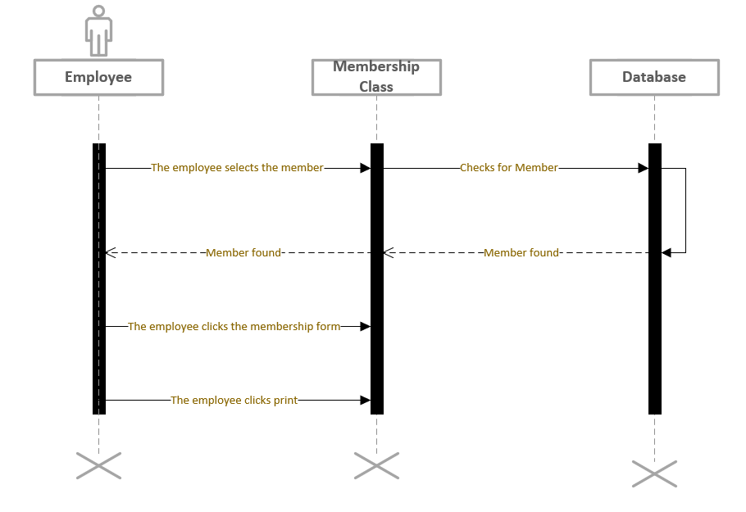

Basic Flow

1. The member navigates to the website.

2. The member selects “Online Membership Form”

3. The member prints the form.

Use case 2:

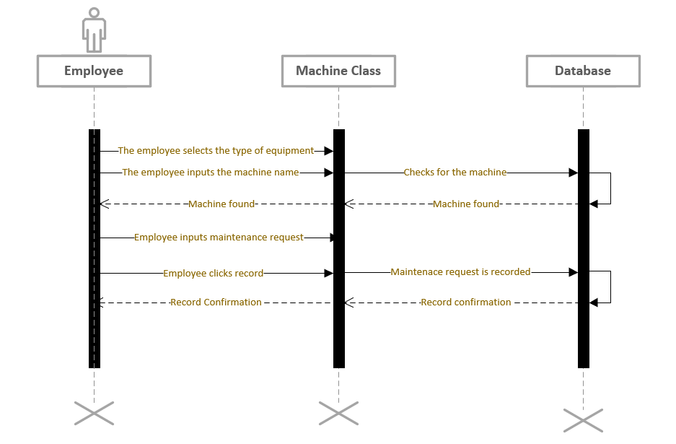

Basic Flow:

1. The employee navigates to the Machine Maintenance Form.

2. The employee conducts their inspection and updates the form.

3. The member completes their inspection.

Use Case 3:

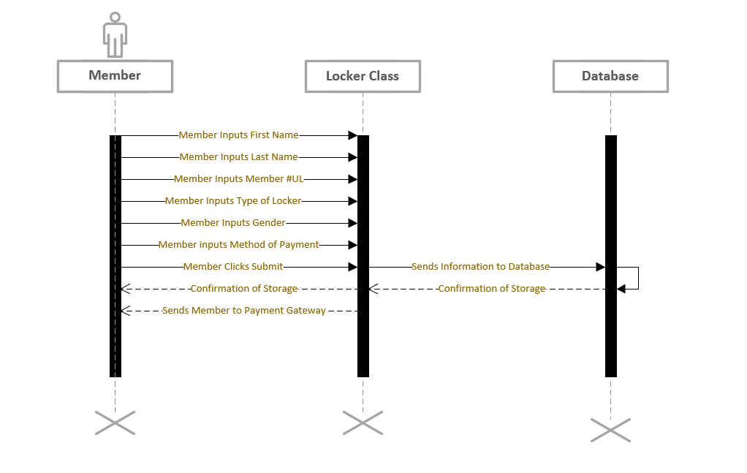

Basic Flow

1. The member navigates to the SRC website.

2. The member clicks “Locker Rental”

3. The member completes the Locker Rental Form.

4. The member continues to payment.

Use Case 4:

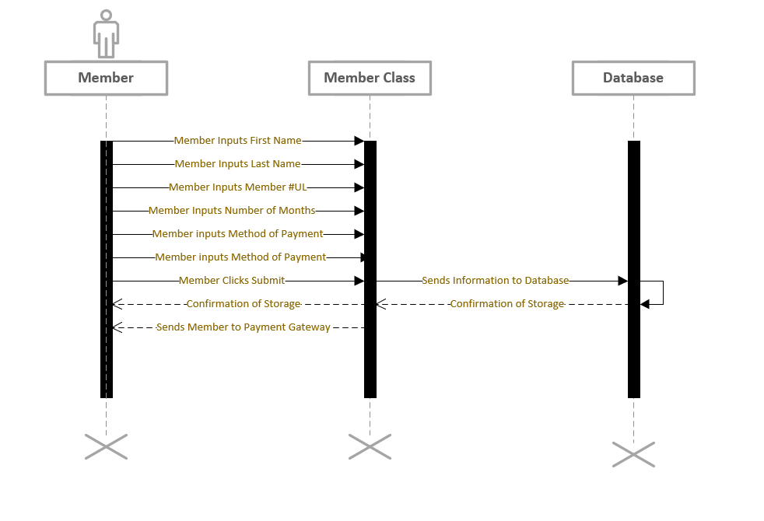

Basic Form

1. The member navigates to the website.

2. The member selects “Online Membership Form”

3. The member completes the Membership Form.

Use Case 5:

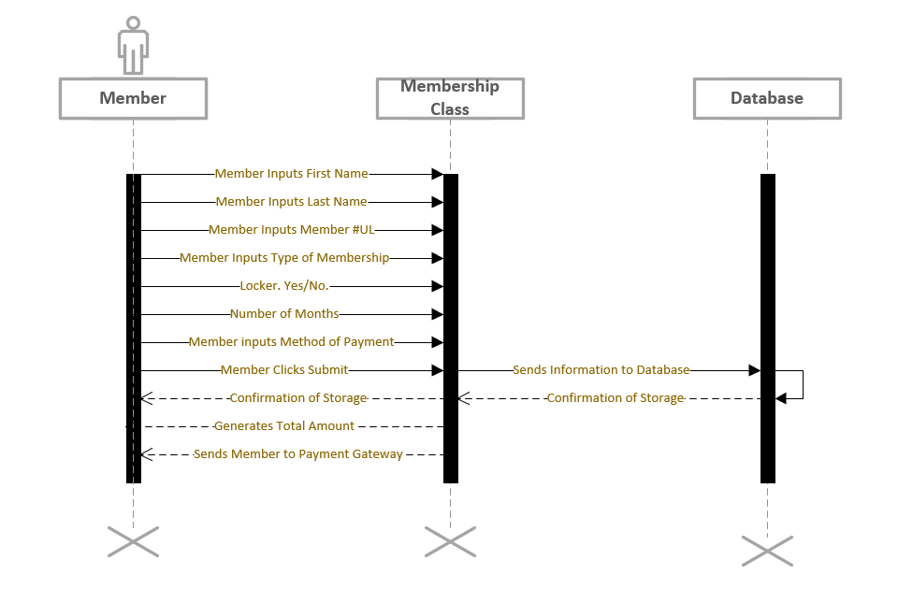

Basic Flow

1. The member navigates to the website.

2. The member selects “Make a Payment.”

3. The member chooses what they are paying for.

4. The system directs the member to the payment gateway.

5. The member inputs payment information.

6. The member completes the payment.

7. The member is offered a receipt.

Use Case 6:

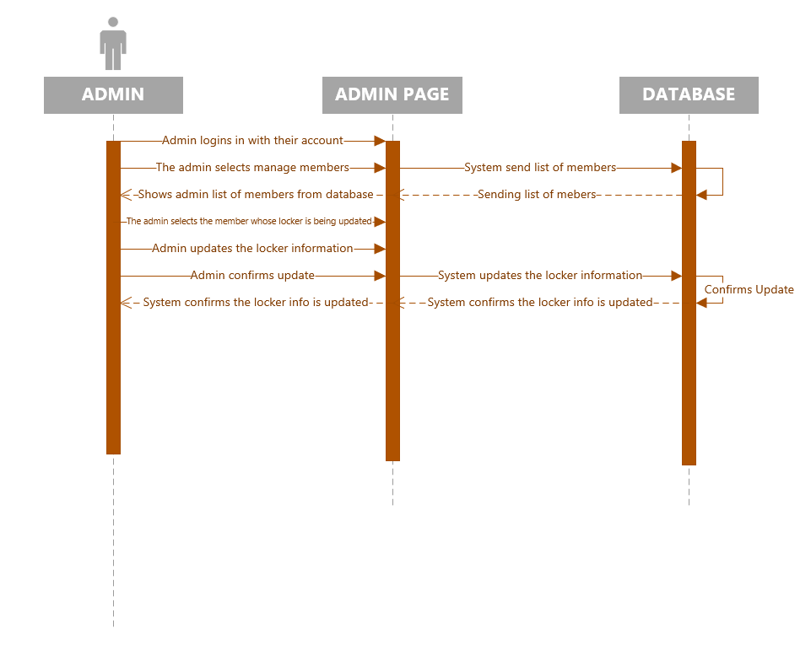

Basic Flow

1. The employee navigates to the website.

2. The employee logs in to their admin account

3. The employee goes to the admin tab

4. The employee clicks on manage members

5. The employee then clicks on the member whose locker rental needs to be changed

6. The employee then enters the information that needs to be changed

7. The employee then confirms the entry

9. System then updates the record

10. Use case ends

Use Case 7:

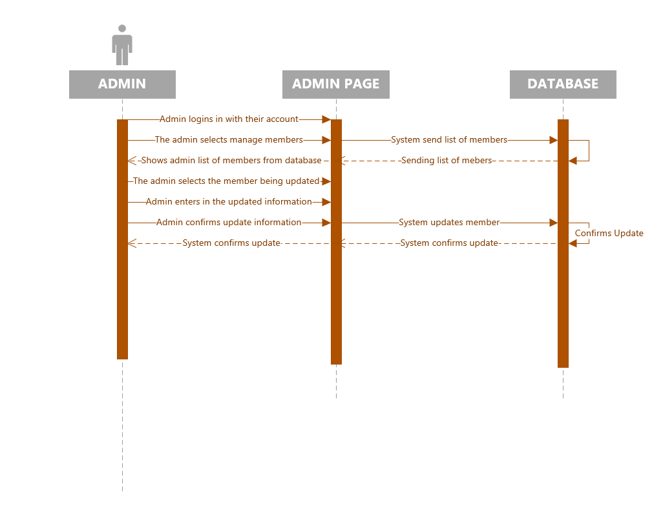

Basic Flow

1. The employee navigates to the website.

2. The employee logs in to their admin account

3. The employee goes to the admin tab

4. The employee clicks on manage members

5. The employee then clicks on the member whose information needs to be changed

6. The employee then changes the necessary information

7. The employee then saves the changes

8. Message appears are you sure you want to save these changes

9. Employee hits yes

10. System then updates the record

Use Case 8:

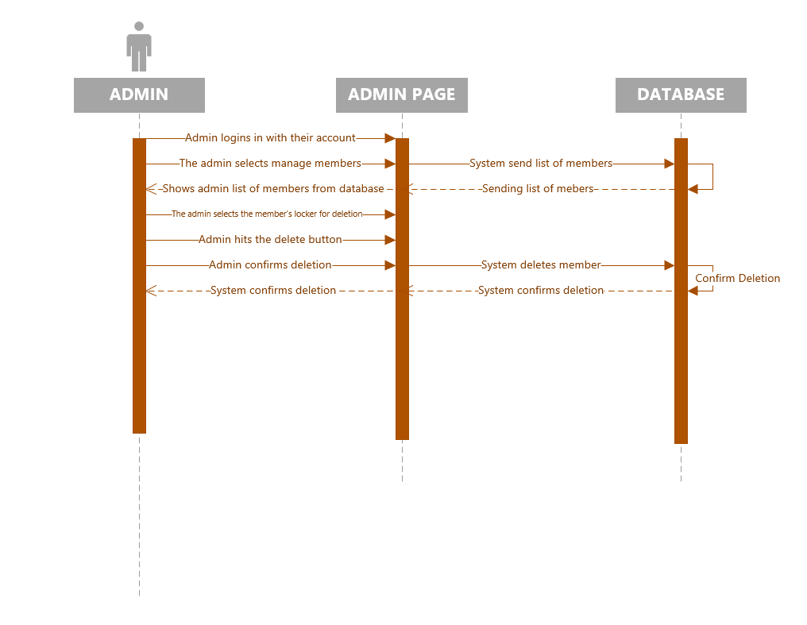

Basic Flow

1. The employee navigates to the website.

2. The employee logs in to their admin account

3. The employee goes to the admin tab

4. The employee clicks on manage members

5. The employee then enters in the locker number whose rental is to be deleted

6. The employee then hits the delete button

7. The employee then has to hit confirm on a banner that appears confirming the deletion

8. Employee hits confirm

9. System then deletes the record

Use Case 9:

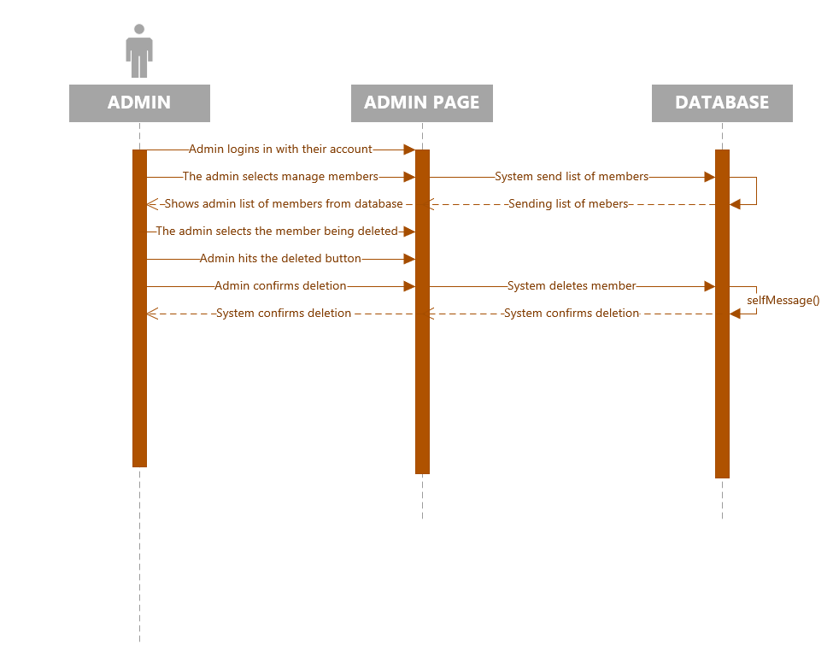

Basic Flow

1. The employee navigates to the website.

2. The employee logs in to their admin account

3. The employee goes to the admin tab

4. The employee clicks on manage members

5. The employee then clicks on the member whose information needs to be deleted

6. The employee then hits the delete button

7. The employee then has to hit confirm on a banner that appears confirming the deletion

8. Employee hits confirm

9. System then deletes the record

Use Case 10:

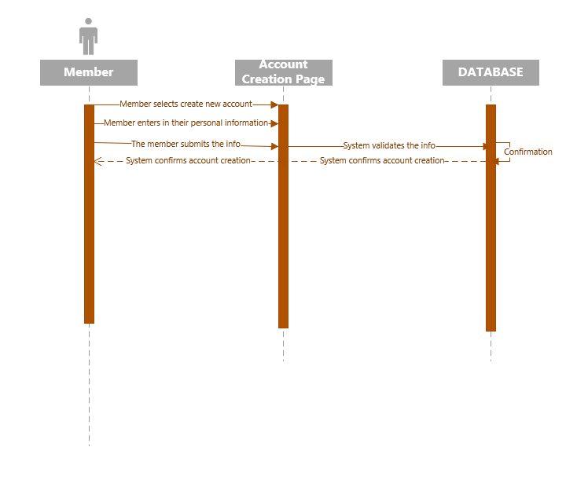

Basic Flow

1. The customer navigates to the website

2. The customer hits the create an account button

3. A window pops up asking the customer for their information

4. The customer enters in their first name

5. The customer enters their last name

6. The customer enters in their email address, which will be the user name for the account

7. The customer enters in their address

8. The customer enters in their sex

9. The customer enter in their race

10. The customer enters in the password for their account

11. The customer submits the information

12. The system creates the account

Use Case #11 Remove Locker Record

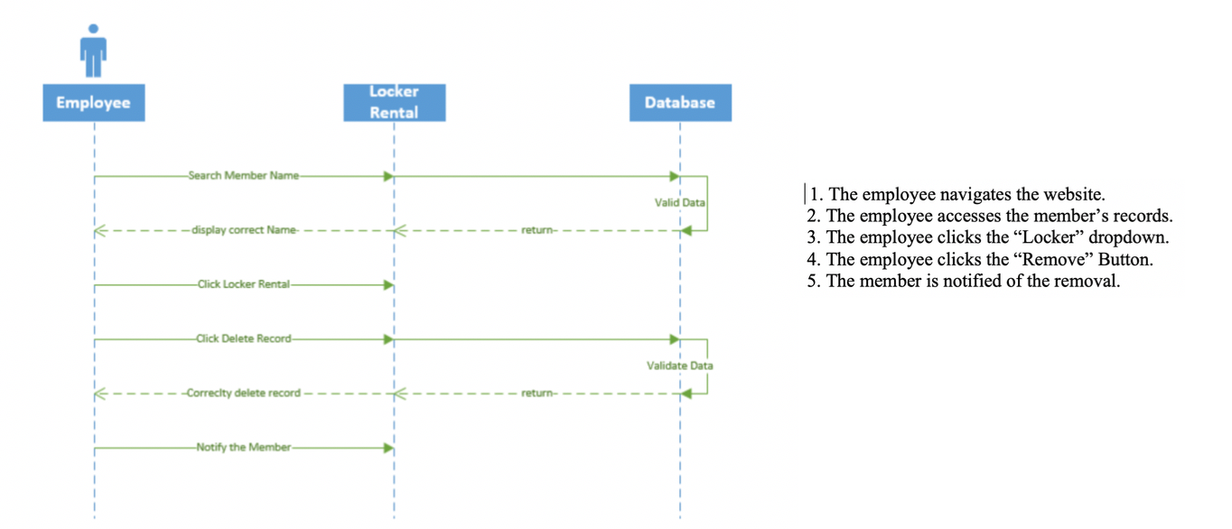

Use Case #12 Membership Renewal Notice

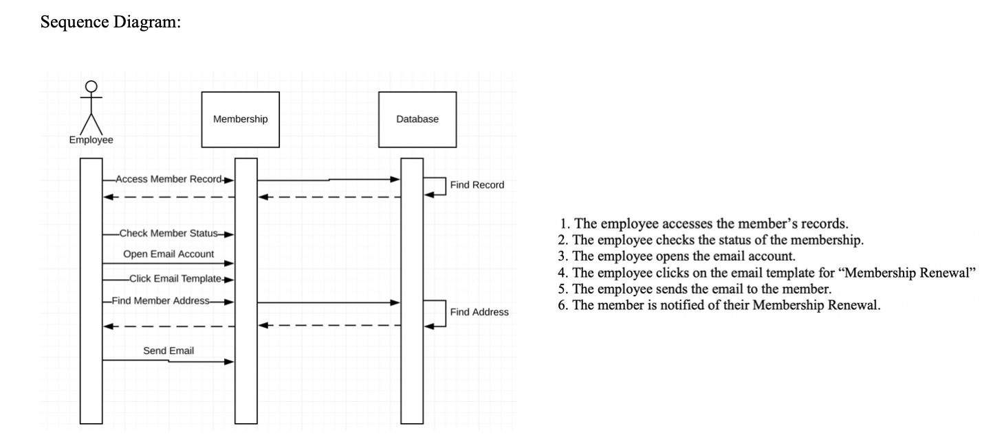

Use Case #13 Membership Feedback Survey

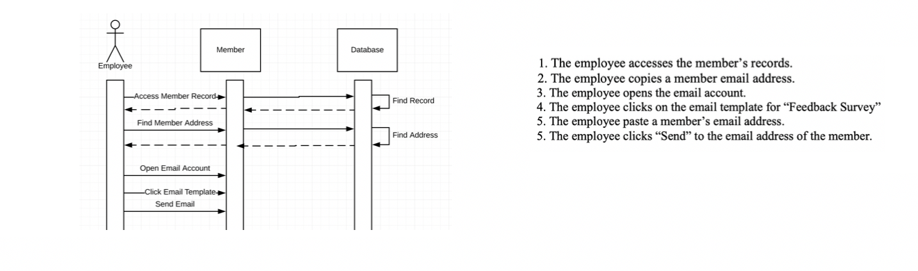

Use Case #14 Display SRC Services

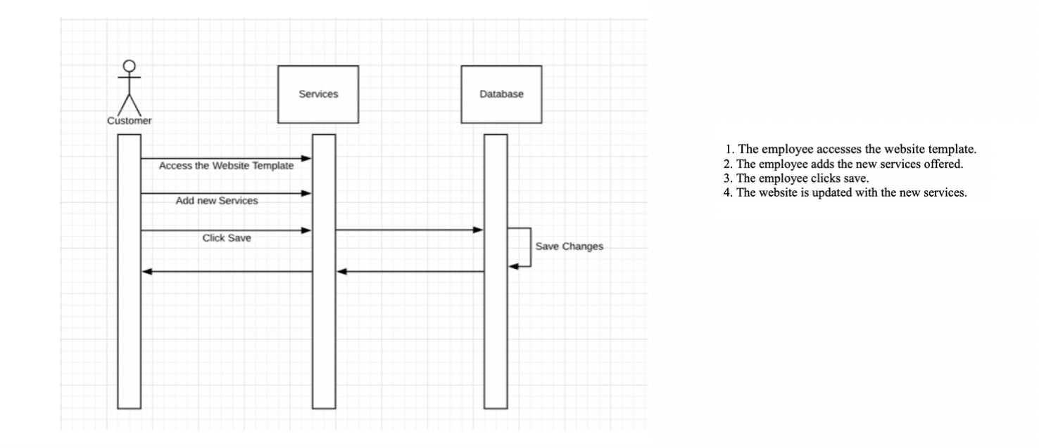

Use Case #15 Membership Check:

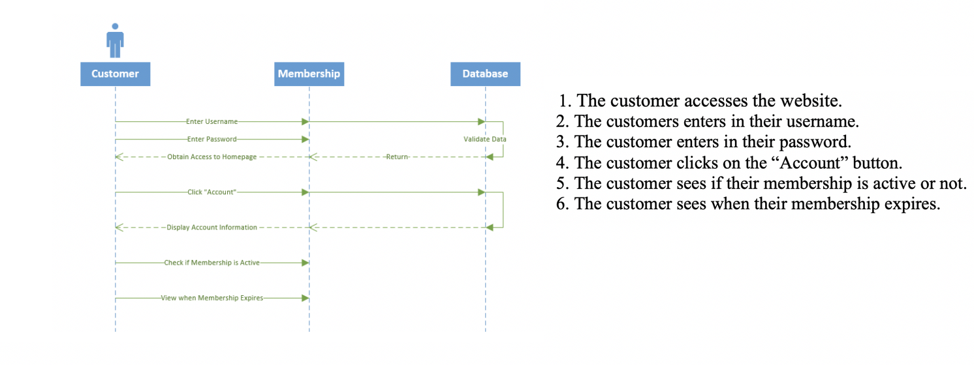

Use Case 16: Web Login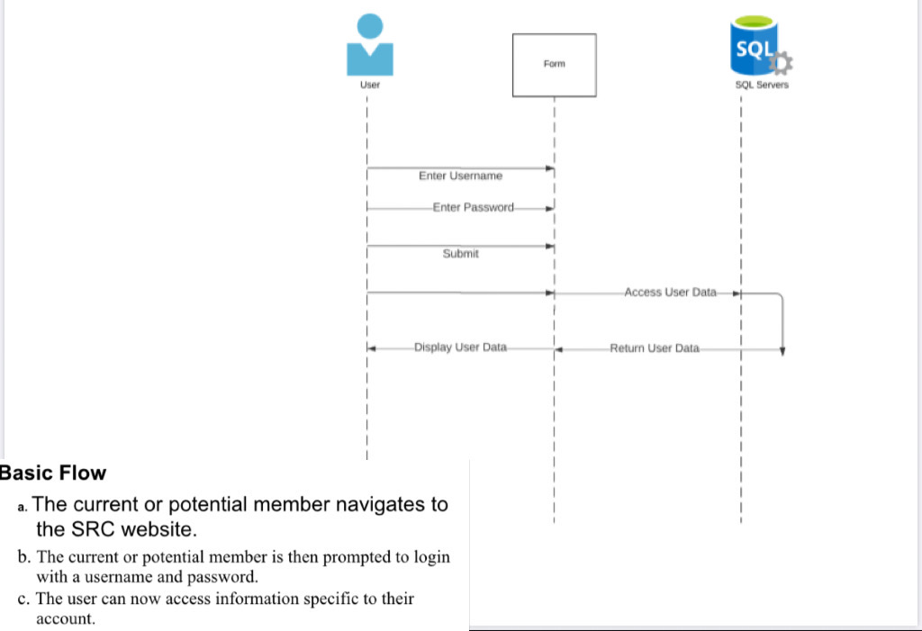

Use Case 17: Locker Expiration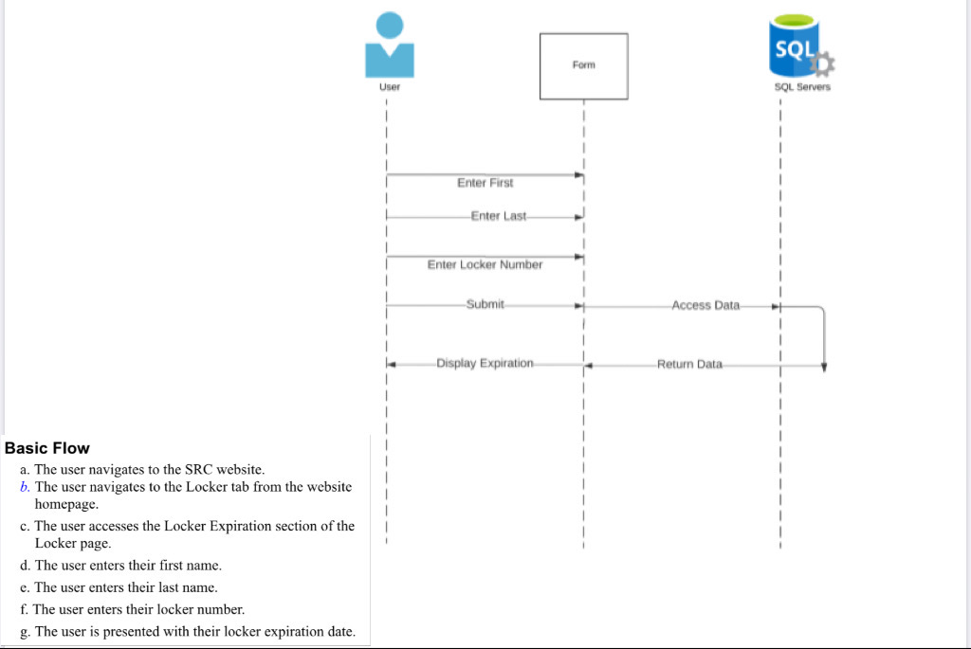

Use Case 18: Locker Reservation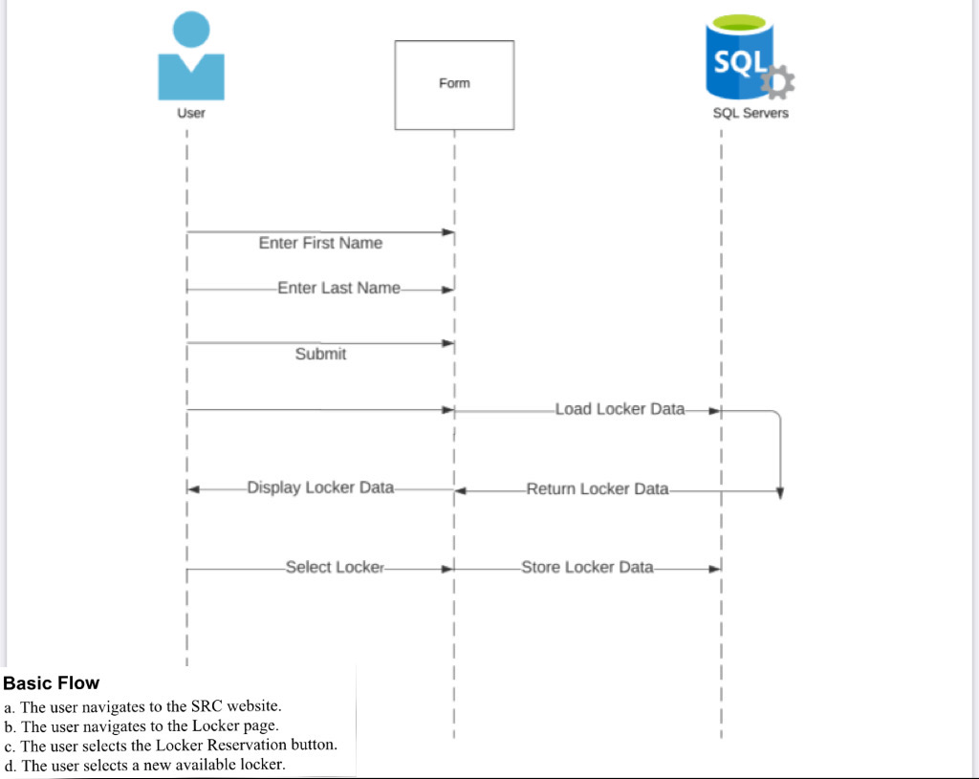

Use Case 19: Locker Membership Bundle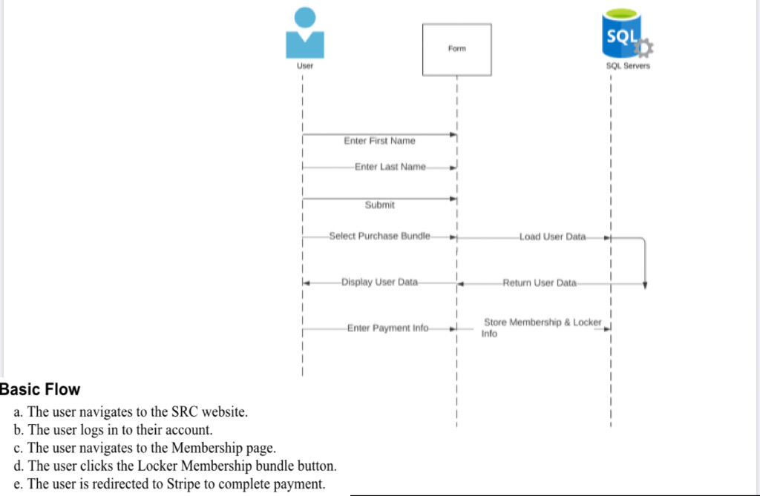

Use Case 20: Survey

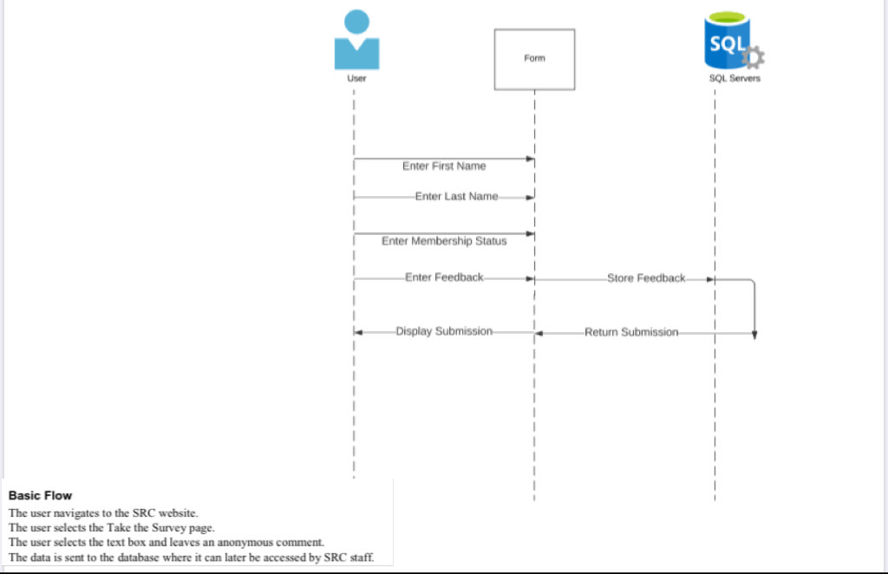

Use Case #21: Gym Usage

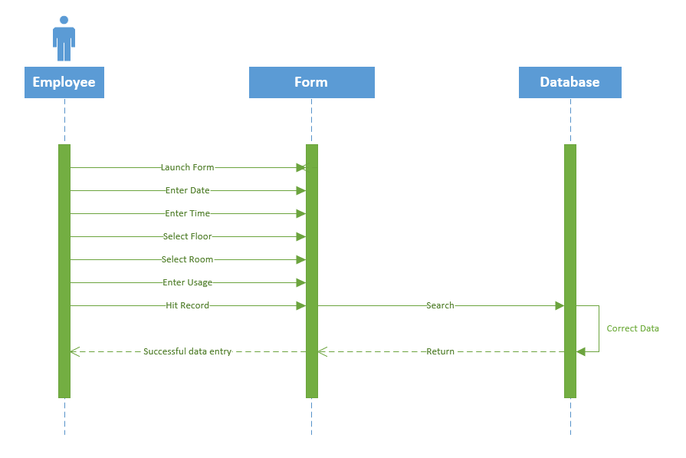

Basic Flow

* The employee must turn on the tablet at the beginning of the day
* The employee will launch the form on the tablet
* The employee will enter the date into the form
* The employee will enter the time into the form
* The employee will enter SRC visitor demographics into a form

Use Case #22: Equipment Usage

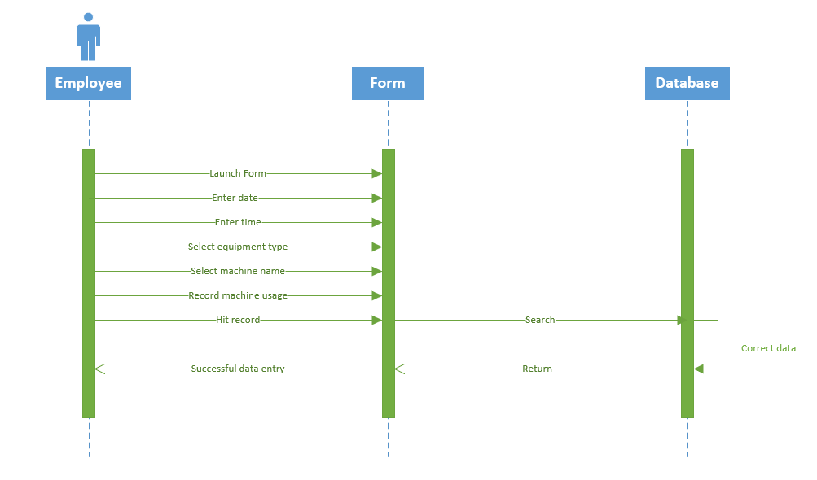

Basic Flow

* The employee will power up the tablet at the beginning of the day
* The employee will launch the form to start counting the equipment usage
* The employee will enter the date into the form
* The employee will enter the time into the form
* The employee will enter the number of visitors using each piece of equipment

Use Case #23: Reporting

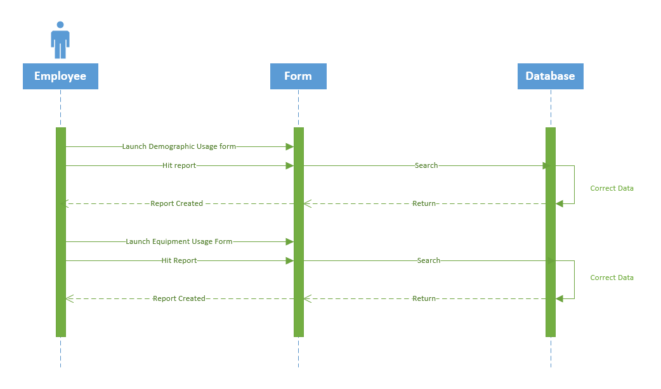

Basic Flow

* The employee will launch the forms on the tablet
* The employee will make the final data entry for the forms
* The employee will hit Report on the bottom of the demographic form
* The employee will hit Report on the bottom of the equipment maintenance form
* The database will create the forms

Use Case #24: Employee Invalid Entry

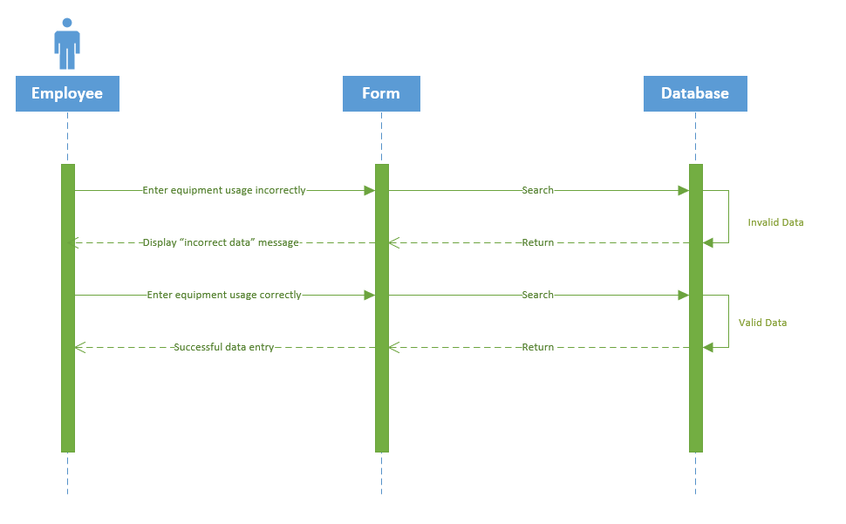

Basic Flow

* The employee is using the tablet and form to input gym or equipment usage
* The employee enters the wrong type of data into a field
* The form recognizes the error
* The form alerts the employee of the error
* The form forbids the customer from continuing without fixing the error

Use Case #25: Customer Invalid Entry

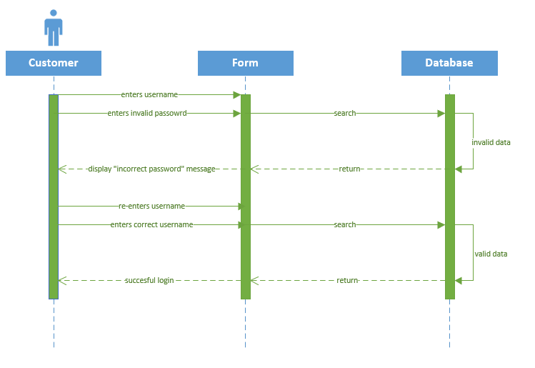

Basic Flow

* The customer enters data into the login form
* The data is an invalid data type, such as a number in a character field
* The form will catch the error
* The form will alert the customer that the input was invalid

Use Case #26: Expiring Memberships

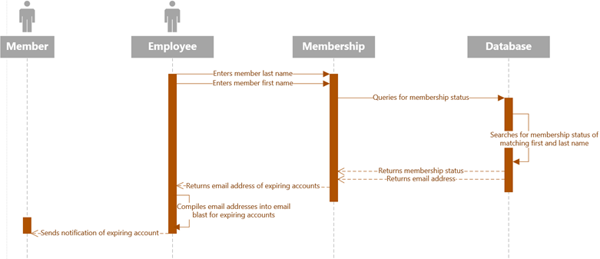

Basic Flow

* The database calculates the time to membership expiration at opening time
* The database flags any member with time to expiration at 7 days
* The database collects the emails of the affected accounts
* An employee receives list of expiring memberships
* An employee creates email
* An email blast is sent to members with expiring accounts

Use Case #27: Expiring Locker Rentals

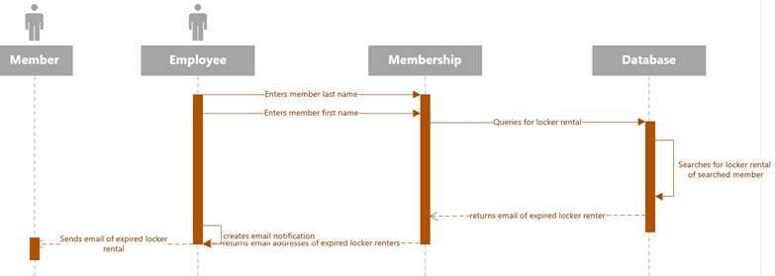

Basic Flow

* An employee queries the database for memberships with lockers.
* An employee queries the database for expired locker rentals.
* The database returns the email address for each affected account.
* An employee creates an email blast for the returned email addresses.
* An employee notifies members with expired locker rentals of the expiration.

Use Case #28: Verifying Payment

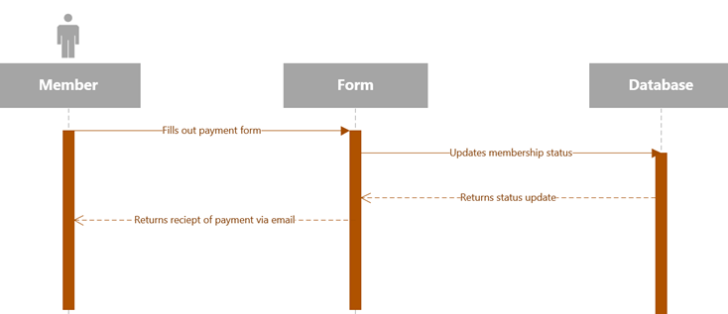

Basic Flow

* The member navigates to the website.
* The member selects “Online Membership Form”.
* The member completes the membership form.
* The member proceeds to payment.
* The member completes payment information.
* The member pays for desired length of membership.
* The member receives a receipt via email for payment of membership.

Use Case #29: Email Blasts

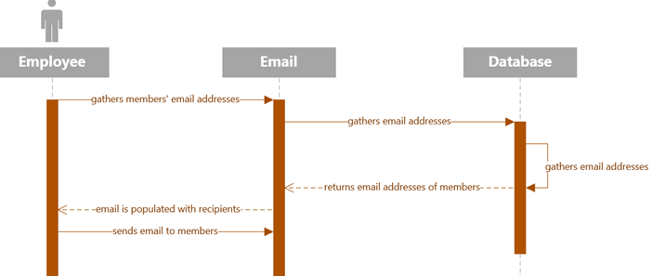Basic Flow

* An employee gathers email addresses of desired members.
* An employee writes email with desired purpose to members.
* An employee adds the email addresses of desired members to pre-composed email.
* Members receive email from employee.

Use Case #30: Access Offline

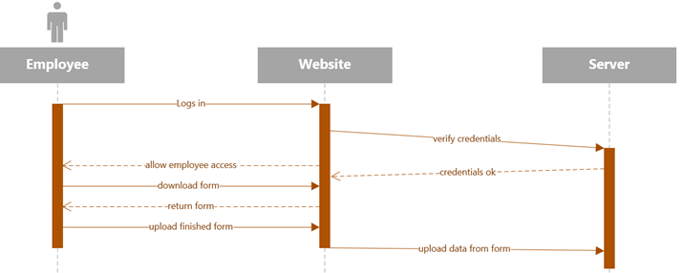Basic Flow

* An employee navigates the website to the data collection forms.
* The employee selects the usage form.
* The employee performs the tracking of the machine/area usage.

**Class Diagram:**

This class diagram describes the structure of the system using the system’s classes, attributes, and operation and the relationship between them.

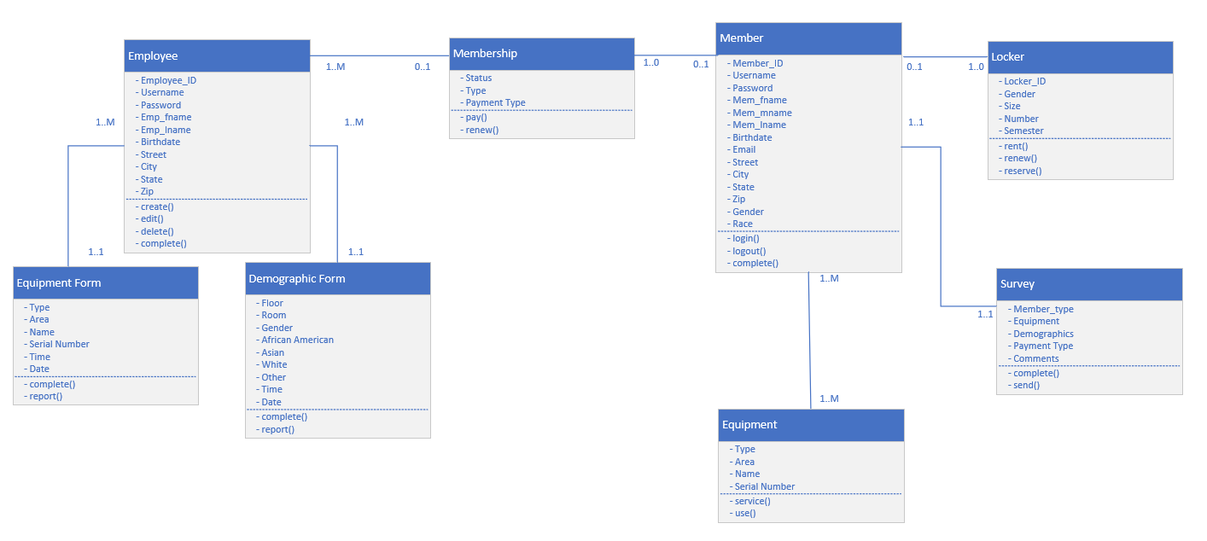

Noun-Verb Analysis

Employee

* an employee can create a member
* an employee can delete a member
* an employee can edit a member
* an employee can complete a form
* an employee can submit a form
* an employee can print a form
* an employee can manage equipment

Equipment Form & Demographic Form

* a form can report data

Member

* a member can login to their account
* a member can logout of their account
* a member can use equipment
* a member can rent a locker
* a member can pay for a locker
* a member can pay for membership
* a member can complete a survey

**Database Design:**

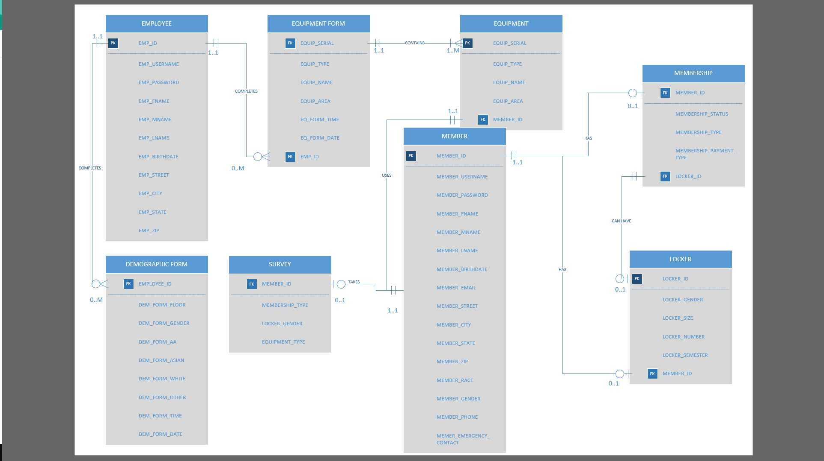

The database design illustrates the various entities present in a system and helps to visualize how each entity is connected. In the database design there are primary keys (identified as PK) which show the main attribute of an entity that may be used by another entity where they become a foreign key (identified as FK). Connecting each entity is a line of cardinality which has a brief description of how the two are connected as well as how many of each entity can be involved in each relationship.

**Data Dictionary**

A Data Dictionary is a set of information from our requirements that describes the name, data type, data format, and the field size of a database. These charts benefit the programmer and other members of the team who will need them when the project is in motion. This collection of data is helpful to make sure that all of the team members are aware of the data that will go into a certain project. We split each table up in eight tables to show the relationship between the fields and how they are interconnected.

Locker

|  |  |  |  |  |  |
| --- | --- | --- | --- | --- | --- |
| **Field Name** | **Data Type** | **Data Format** | **Field Size** | **Description** | **Example** |
| **Locker_ID** | **Integer** | **123456** | **6** | **The ID associated with each specific locker in the database system.** | **123456** |
| **Gender** | **String** | **F/M** | **2** | **The gender of the person who is associated with the locker.** | **F** |
| **Size** | **String** | **Half/Full** | **4** | **The size of the locker that is being rented out.** | **Half** |
| **Number** | **Integer** | **123** | **3** | **The number on the front of the locker that is being rented.** | **200** |
| **Semester** | **String** | **Fall/Spring/Summer** | **6** | **The semester when the locker is being rented out for.** | **Fall** |

Survey

|  |  |  |  |  |  |
| --- | --- | --- | --- | --- | --- |
| **Field Name** | **Data Type** | **Data Format** | **Field Size** | **Description** | **Example** |
| **Member Type** | **String** | **Student/Staff/Alumni** | **7** | **This describes the member's status at UofL** | **Staff** |
| **Equipment** | **String** | **Cardio/Strength** | **8** | **This describes the type of equipment the member is referring to.** | **Cardio** |
| **Member Demographics** | **String** | **Race/Gender/Age** | **6** | **This describes specific attributes about the member.** | **C/F/21** |
| **Payment Type** | **String** | **Cash, Card, Check** | **5** | **This is the type of payment to user paid with.** | **Cash** |
| **Comments** | **String** |  | **200** | **This is the comments the user leaves as feedback.** | **The cycling machine on the 2nd floor is broken.** |

Member

|  |  |  |  |  |  |
| --- | --- | --- | --- | --- | --- |
| **Field Name** | **Data Type** | **Data Format** | **Field Size** | **Description** | **Example** |
| **Member_ID** | **String** | **123456** | **6** | **This is the ID associated with the member in the system.** | **111112** |
| **Member_FName** | **String** |  | **30** | **This is the member's first name.** | **Brae** |
| **Member_Lname** | **String** |  | **30** | **This is the member's last name.** | **Merriman** |
| **Birth_Date** | **Date/Time** | **11/11/1111** | **10** | **This is the member's date of birth.** | **11/30/1998** |
| **Username** | **String** | **abcd01** | **6** | **This is the member's username to access the system.** | **bemerr02** |
| **Password** | **String** |  | **20** | **This is the member's password to access the system.** | **PASSword123** |

Equipment

|  |  |  |  |  |  |
| --- | --- | --- | --- | --- | --- |
| **Field Name** | **Data Type** | **Data Format** | **Field Size** | **Description** | **Example** |
| **Type** | **String** | **Cardio/Strength** | **8** | **This is the type of equipment that is being referenced.** | **Cardio** |
| **Name** | **String** |  | **30** | **This is the name of the equipment being referenced.** | **Treadmill** |
| **Area** | **Integer** | **1/2/3/4** | **1** | **This is the floor the equipment is located on.** | **2** |
| **Serial_Num** | **Integer** | **1234567890** | **10** | **This is the serial number on the equipment.** | **1122334455** |

Membership

|  |  |  |  |  |  |
| --- | --- | --- | --- | --- | --- |
| **Field Name** | **Data Type** | **Data Format** | **Field Size** | **Description** | **Example** |
| **Status** | **String** | **Staff/Student/Alumni** | **7** | **This is the status of the member at the university.** | **Student** |
| **Type** | **String** | **Year, Semester** | **8** | **This is the length of membership the member has.** | **Semester** |
| **Payment** | **String** | **Cash, Card, Check** | **5** | **This is the payment type used by the member.** | **Cash** |

Demographics Form

|  |  |  |  |  |  |
| --- | --- | --- | --- | --- | --- |
| **Field Name** | **Data Type** | **Data Format** | **Field Size** | **Description** | **Example** |
| **Floor** | **Integer** | **1/2/3/4** | **1** | **This is the floor the staff is evaluating.** | **2** |
| **Room** | **Integer** | **123** | **3** | **This is the room the staff is evaluating.** | **201** |
| **Gender** | **String** | **M/F** | **1** | **This is the gender the staff evaluates using equipment.** | **F** |
| **Race** | **String** | **C/AA/O** | **2** | **This is the race the staff counts of members using equipment.** | **C** |
| **Time** | **Date/Time** | **12:00:00** | **8** | **This is the time the staff does the report.** | **22:49:01** |
| **Report** | **Button** |  | **1** | **This is the report the staff generates from the count.** | **Submit** |
| **Date** | **Date/Time** | **1/1/1901** | **10** | **This is the date of when the report is generated.** | **12/4/2019** |

Equipment Form

|  |  |  |  |  |  |
| --- | --- | --- | --- | --- | --- |
| **Field Name** | **Data Type** | **Data Format** | **Field Size** | **Description** | **Example** |
| **Type** | **String** | **Cardio/**  **Strength** | **8** | **This is the type of equipment being evaluated.** | **Cardio** |
| **Area** | **Integer** | **1/2/3/4** | **1** | **This is the floor where the equipment is located.** | **1** |
| **Name** | **String** |  | **30** | **This is the name of the equipment being evaluated.** | **Treadmill** |
| **Serial_Num** | **Integer** | **1234567890** | **10** | **This is the serial number on the equipment.** | **1122334455** |
| **Date** | **Date/Time** | **1/1/1901** | **10** | **This is the date when the form is being filled out.** | **12/4/2019** |

Employee

|  |  |  |  |  |  |
| --- | --- | --- | --- | --- | --- |
| **Field Name** | **Data Type** | **Data Format** | **Field Size** | **Description** | **Example** |
| **Employee_ID** | **Integer** | **123456** | **6** | **This is the ID number associated with the employee in the system.** | **112233** |
| **Username** | **String** | **abcd01** | **6** | **This is the employee's username to access the system.** | **bemerr02** |
| **Password** | **String** |  | **20** | **This is the employee's password to access the system.** | **PASSword12** |
| **Emp_FName** | **String** |  | **30** | **This is the employee's first name.** | **Brae** |
| **Emp_Lname** | **String** |  | **30** | **This is the employee's last name.** | **Merriman** |

User Interface Navigation Diagram:

SHANE - don’t forget a narrative

Screen Layouts:

SHANE - don’t forget a narrative

Physical Architecture Design:

This model shows an example of what the future system could look like. It graphically shows how the employee and the members will interact with the system, and how the system will interact with the external servers.

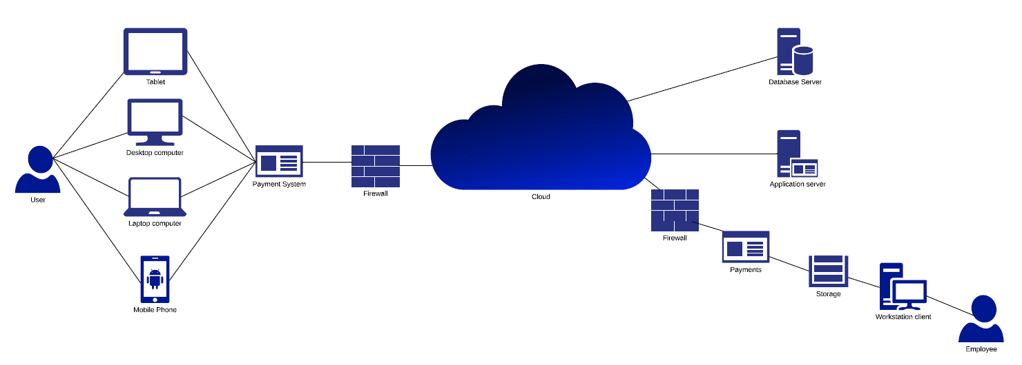

Gantt Chart:

A Gantt Chart is useful in showing the tasks or events that are displayed over a period of time. Each task is represented by a bar and the position and length of the bar reflects the start, duration, and end of the distinguished activity. This visual shows the business owner what the various activities are, when a certain activity begins and ends, how long activities will last, and most importantly the start and end date of the project. This Gantt Chart shows the project tasks for all of our iterations.

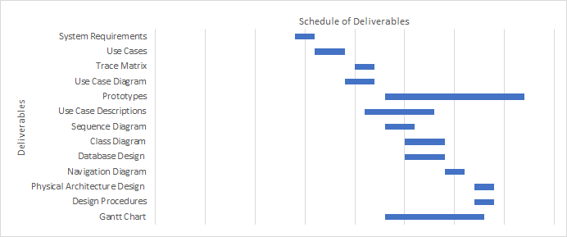

On the following page please see the task dependencies.

Task Dependencies

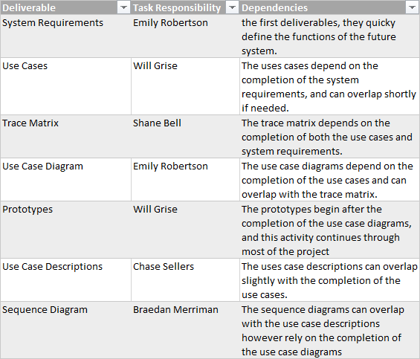

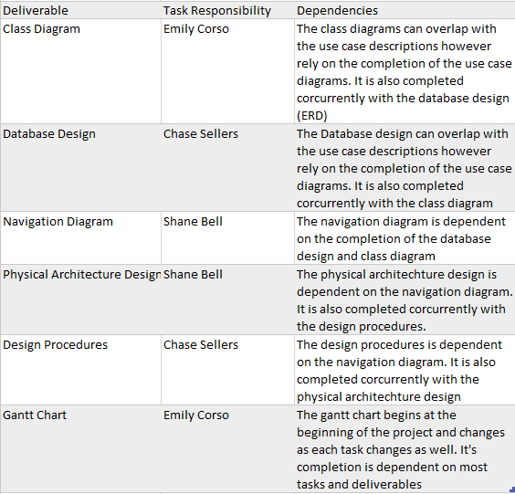

**Design Procedures for Security Concerns and Non-functional Requirements**

Members

The customers will have their own account that they can manage and that they can sign in from any computer that they want to. They will have an email address for their username and password that they will choose. The customers will have to authenticate themselves when they log in to make sure that it is them.

Staff

Staff will have an admin account that can access the database and so she can do whatever she needs to do to her orders. Staff will be able to log in from that account from any computer that allows them to access the website.

Backup / restore

For the backup and restore for all the information will be done in the cloud. This is so we can ensure the data is securely stored off-site and it will be easily accessible in case we need to recover the system.

Security

It is important that the system be behind the university firewall to prevent unauthorized tampering with the website. The system should also require staff to change their password on a regular basis to reduce the chance of an attacker obtaining the password. We must also ensure the system is properly maintained and that the security levels of users are properly managed to avoid an internal tampering or potential sabotage. There should be a system administrator who is in charge of maintaining the security levels for the system.

**Elaboration Phase Prototypes:**

Use case 1: Print Form

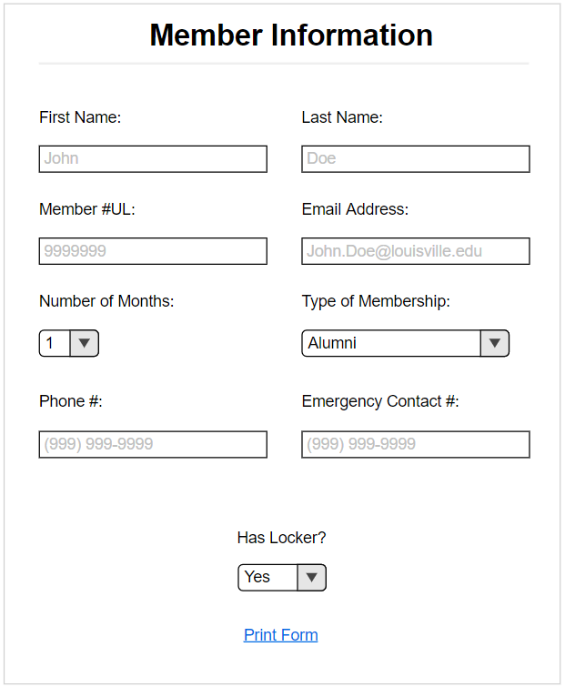

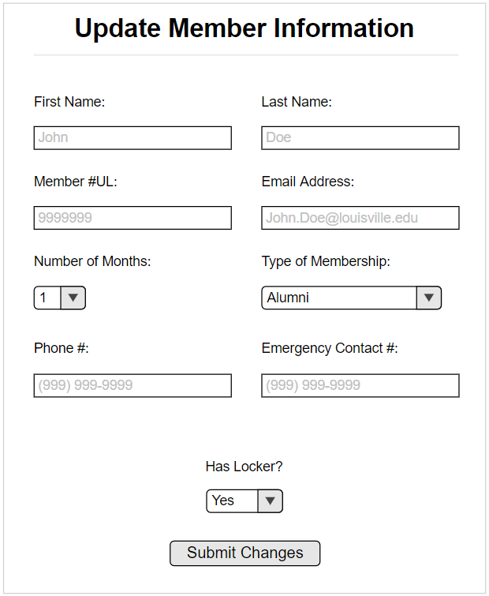

Use Case #3: Complete Locker Form

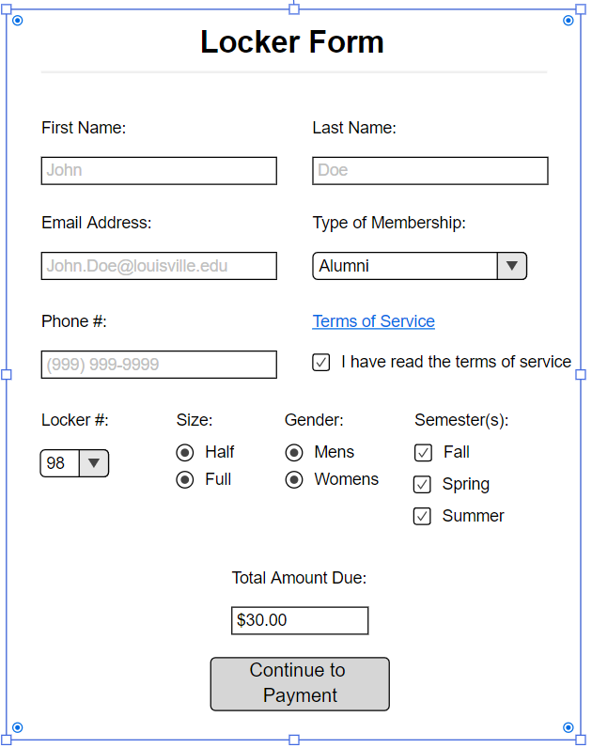

Use Case #4: Complete Membership Form

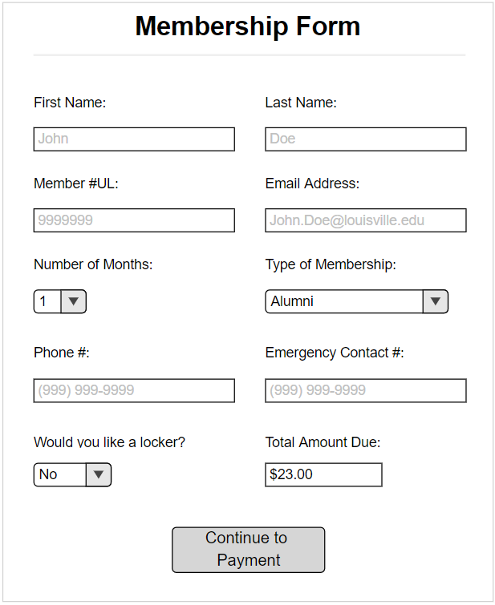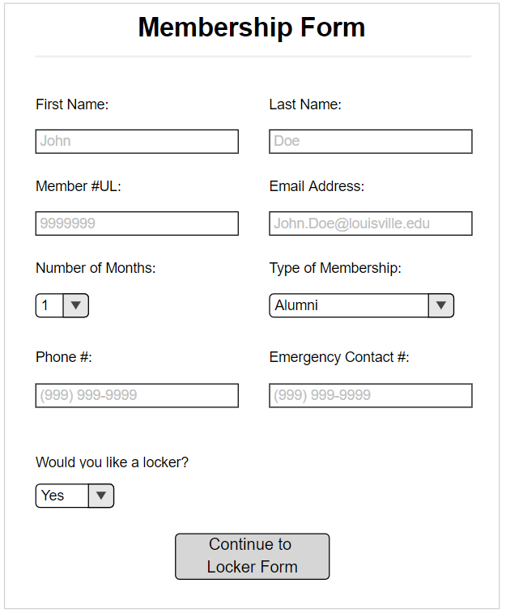

Use Case 21: Demographics Form

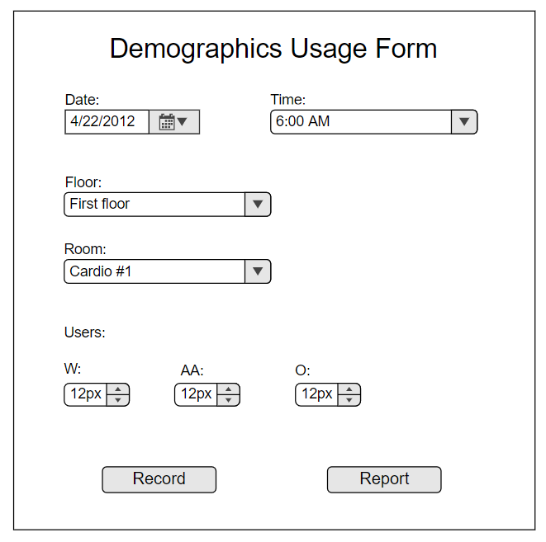

Use Case #22: Equipment Usage Form

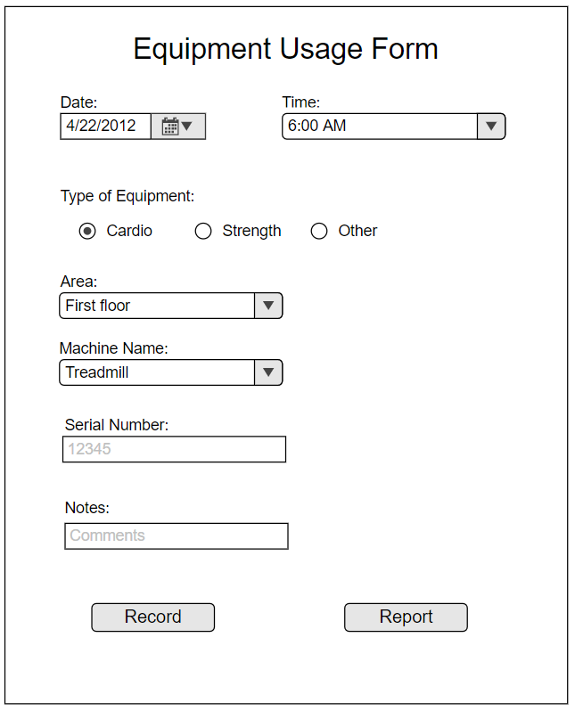

Use Case #26: Expiring Membership

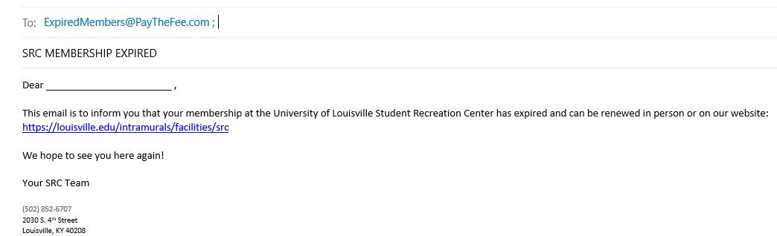

Use Case #27: Expiring Locker Rental

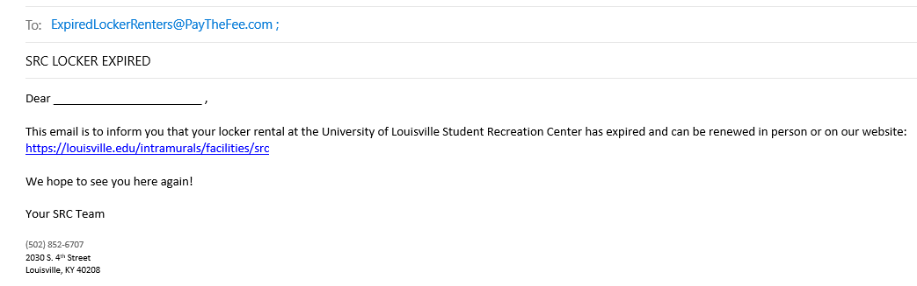

Use Case #28: Verifying Payment

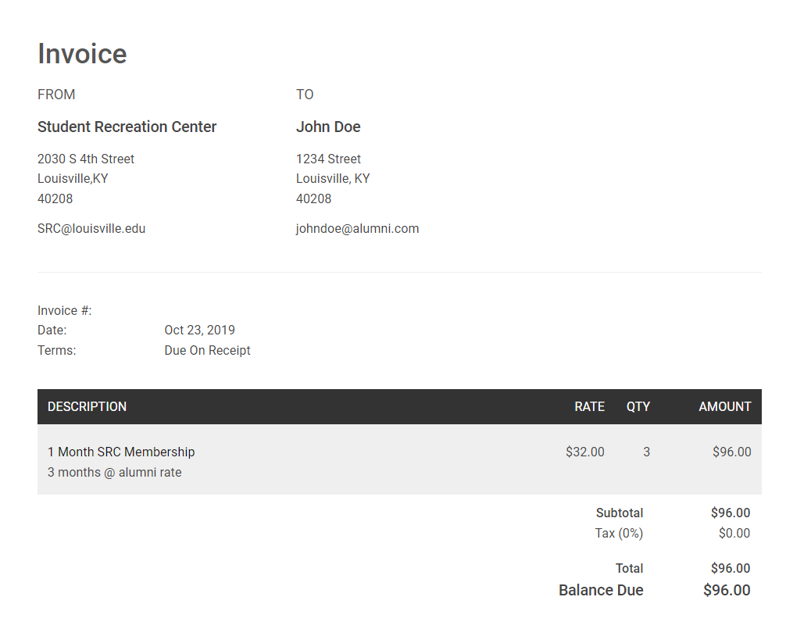

Use Case #29: Email Blasts

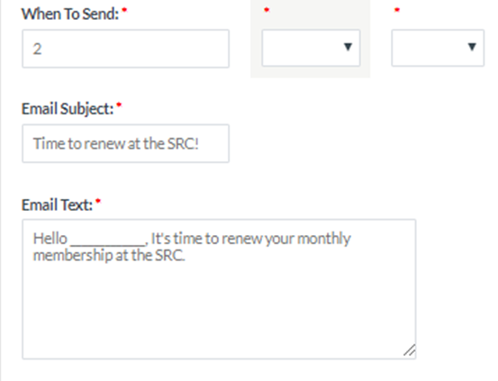

Use Case #30: Access Offline

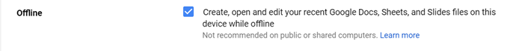

Login

